David Willis

Lingma Acheson

CIT 304

2.27.2018

Midterm Presentation

**Items 1, 2**

The information provided within this database is taken from the first 250 rows of the “Top Anime” section of the MyAnimeList (<https://myanimelist.net/topanime.php>) website. The target audience is geared towards anime and manga fanatics and enthusiasts, especially individuals searching for new anime to watch (or new manga to read). The end user may filter their anime related searches via its current air status (completed or ongoing), genre, rating (G to R in regard to age-appropriate content), total episode count, air dates, manga volumes and chapters along with the air status, studio and soundtrack information, score rating (based upon MyAnimeList registered members voting on a scale from 1 to 10), ranking compared to all other scored anime in the MyAnimeList database, and serialization information (manga publishing company along with the first and last publishing dates). Some people may find and watch new anime via browsing Netflix or Hulu; however, these television shows are rated anybody willing to rate a show. Some shows will be down voted by non-anime fans without the refined taste for this particular cartoon archetype. Also, Netflix and Hulu do not give specific genres of anime nor do they rank them in order for others to see. The goal of this database is to grant the end user the ability personalize their searches for anime geared towards their current mood or predisposed tastes (instead of blindly filtering through endless anime lists via Netflix and Hulu that provide no hint towards the enjoyability of a particular show to the end user). For example, a person could filter their search to find anime with the genre of “slice of life” and order the list from the highest to lowest ranking “slice of life” style anime. All users of the database have the access rights to all the data maintained within this anime and manga database; however, only an administrator may edit primary and foreign keys and table and variable information. Non admin users of the database may filter and query the database via any search their imagination may conjure, but they cannot delete any rows or table data.

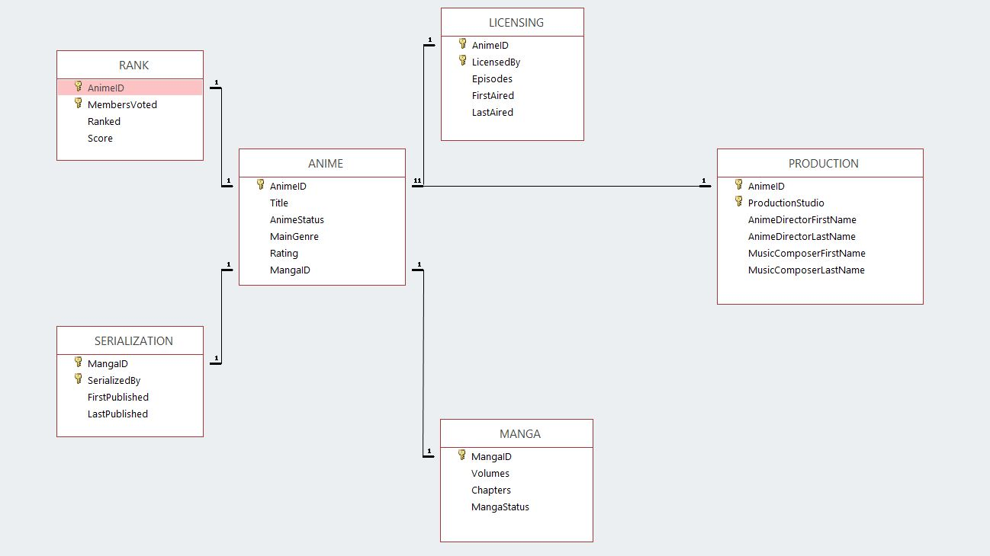

**Items 3, 4, 15**

--Item 3, Have at least five tables

--Table 1; Central Table

CREATE TABLE ANIME_PROJECT (

anime_id varchar2(10) not null,

title varchar2(300),

anime_status varchar2(40),

main_genre varchar2(40),

rating varchar2(10),

--unique constraint

manga_id varchar2(10) UNIQUE,

--use of constraints

PRIMARY KEY (anime_id)

);

INSERT INTO ANIME_PROJECT (anime_id, title, anime_status, main_genre, rating, manga_id)

SELECT ANIMEID, TITLE, ANIMESTATUS, MAINGENRE, RATING, MANGAID FROM ANIME;

-- Table 2, Licensing

CREATE TABLE LICENSING_PROJECT (

anime_id varchar2(10) not null,

licensed_by varchar2(80) not null,

episodes number,

first_aired date,

last_aired date,

PRIMARY KEY (anime_id, licensed_by),

CONSTRAINT FK_anime_id_licensing_table FOREIGN KEY (anime_id)

REFERENCES ANIME_PROJECT (anime_id)

);

INSERT INTO LICENSING_PROJECT (anime_id, licensed_by, episodes, first_aired, last_aired)

SELECT ANIMEID, LICENSEDBY, EPISODES, FIRSTAIRED, LASTAIRED FROM LICENSING;

--Table 3, Manga

CREATE TABLE MANGA_PROJECT (

manga_id varchar2(10) not null,

volumes number,

chapters number,

manga_status varchar2(40),

PRIMARY KEY (manga_id),

CONSTRAINT FK_manga_id_manga_table FOREIGN KEY (manga_id)

REFERENCES ANIME_PROJECT (manga_id)

);

INSERT INTO MANGA_PROJECT (manga_id, volumes, chapters, manga_status)

SELECT MANGAID, VOLUMES, CHAPTERS, MANGASTATUS FROM MANGA;

--Table 4, Production

CREATE TABLE PRODUCTION_PROJECT (

anime_id varchar2(10) not null,

production_studio varchar2(80) not null,

anime_director_first_name varchar2(80),

anime_director_last_name varchar2(80),

music_composer_first_name varchar2(80),

music_composer_last_name varchar2(80),

PRIMARY KEY (anime_id, production_studio),

CONSTRAINT FK_anime_id_production_table FOREIGN KEY (anime_id)

REFERENCES ANIME_PROJECT (anime_id)

);

INSERT INTO PRODUCTION_PROJECT (anime_id, production_studio, anime_director_first_name,

anime_director_last_name, music_composer_first_name,

music_composer_last_name)

SELECT ANIMEID, PRODUCTIONSTUDIO, ANIMEDIRECTORFIRSTNAME, ANIMEDIRECTORLASTNAME,

MUSICCOMPOSERFIRSTNAME, MUSICCOMPOSERLASTNAME FROM PRODUCTION;

--Table 5, Rank

CREATE TABLE RANK_PROJECT (

anime_id varchar2(10) not null,

members_voted number not null,

ranked number,

score number,

PRIMARY KEY (anime_id, members_voted),

CONSTRAINT FK_anime_id_rank_table FOREIGN KEY (anime_id)

REFERENCES ANIME_PROJECT (anime_id)

);

INSERT INTO RANK_PROJECT (anime_id, members_voted, ranked, score)

SELECT ANIMEID, MEMBERSVOTED, RANKED, SCORE FROM RANK;

--Table 6, Serialization

CREATE TABLE SERIALIZATION_PROJECT (

manga_id varchar2(10) not null,

serialized_by varchar2(80) not null,

first_published date,

last_published date,

PRIMARY KEY (manga_id, serialized_by),

CONSTRAINT FK_manga_id_serialization FOREIGN KEY (manga_id)

REFERENCES ANIME_PROJECT (manga_id)

);

INSERT INTO SERIALIZATION_PROJECT (manga_id, serialized_by, first_published, last_published)

SELECT MANGAID, SERIALIZEDBY, FIRSTPUBLISHED, LASTPUBLISHED FROM SERIALIZATION;

--Item 15, Demonstrate Save Points

savepoint anime_project_table_creation;

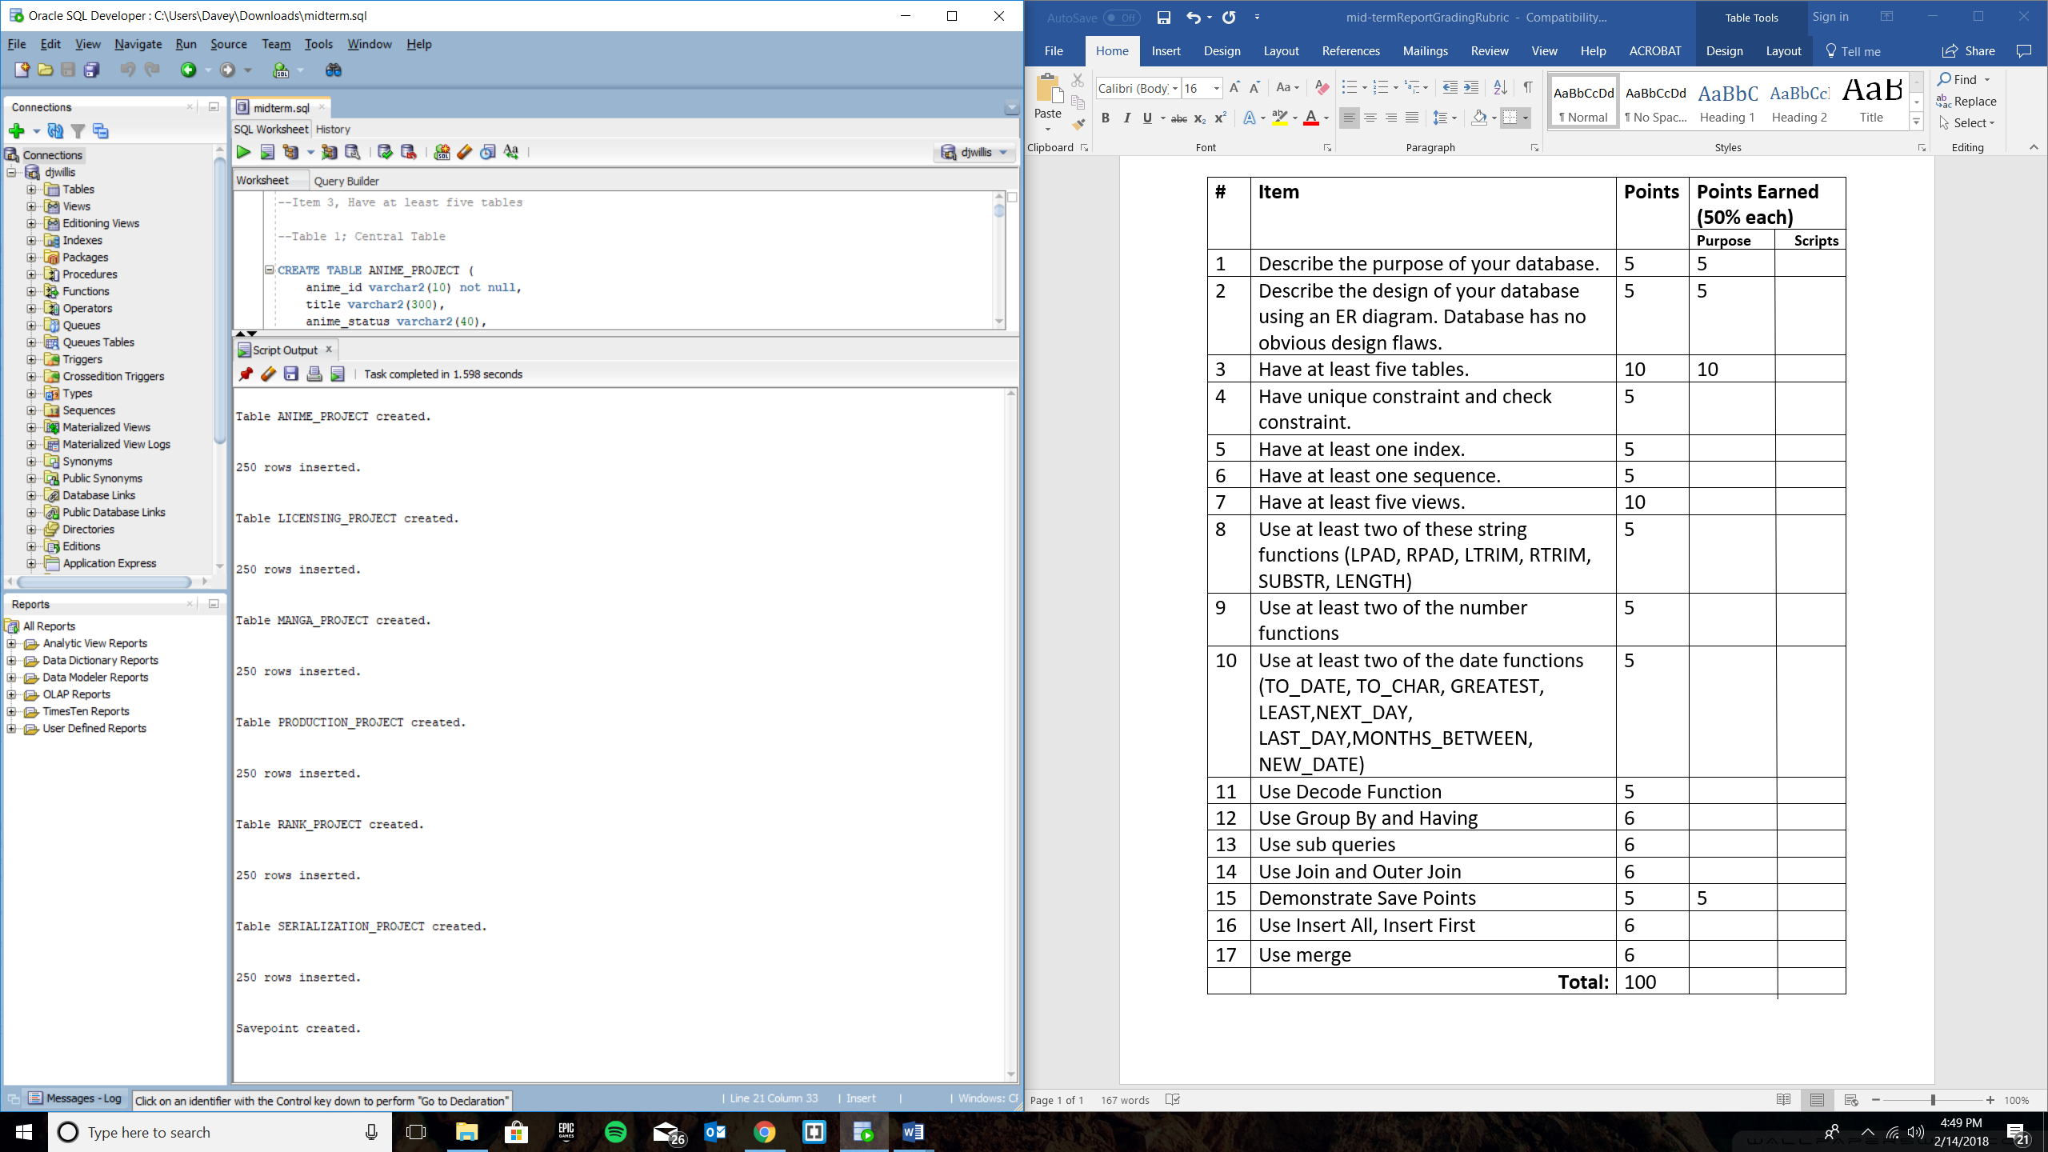

**Item 17, Use Merge**

--Item 17, Use Merge

CREATE TABLE MERGE_EXAMPLE (

anime_id varchar2(10) not null,

title varchar2(300),

anime_status varchar2(40),

anime_status_merged varchar2(40)

);

INSERT INTO MERGE_EXAMPLE (anime_id, title, anime_status)

SELECT ANIMEID, TITLE, ANIMESTATUS FROM ANIME;

MERGE INTO MERGE_EXAMPLE

USING (SELECT 1 FROM DUAL)

ON (anime_status = 'Completed')

WHEN MATCHED THEN UPDATE SET anime_status_merged = 'Finished'

WHEN NOT MATCHED THEN INSERT (anime_status) VALUES ('Completed');

--Item 15, Demonstrate Save Points

savepoint merge_example_save_point;

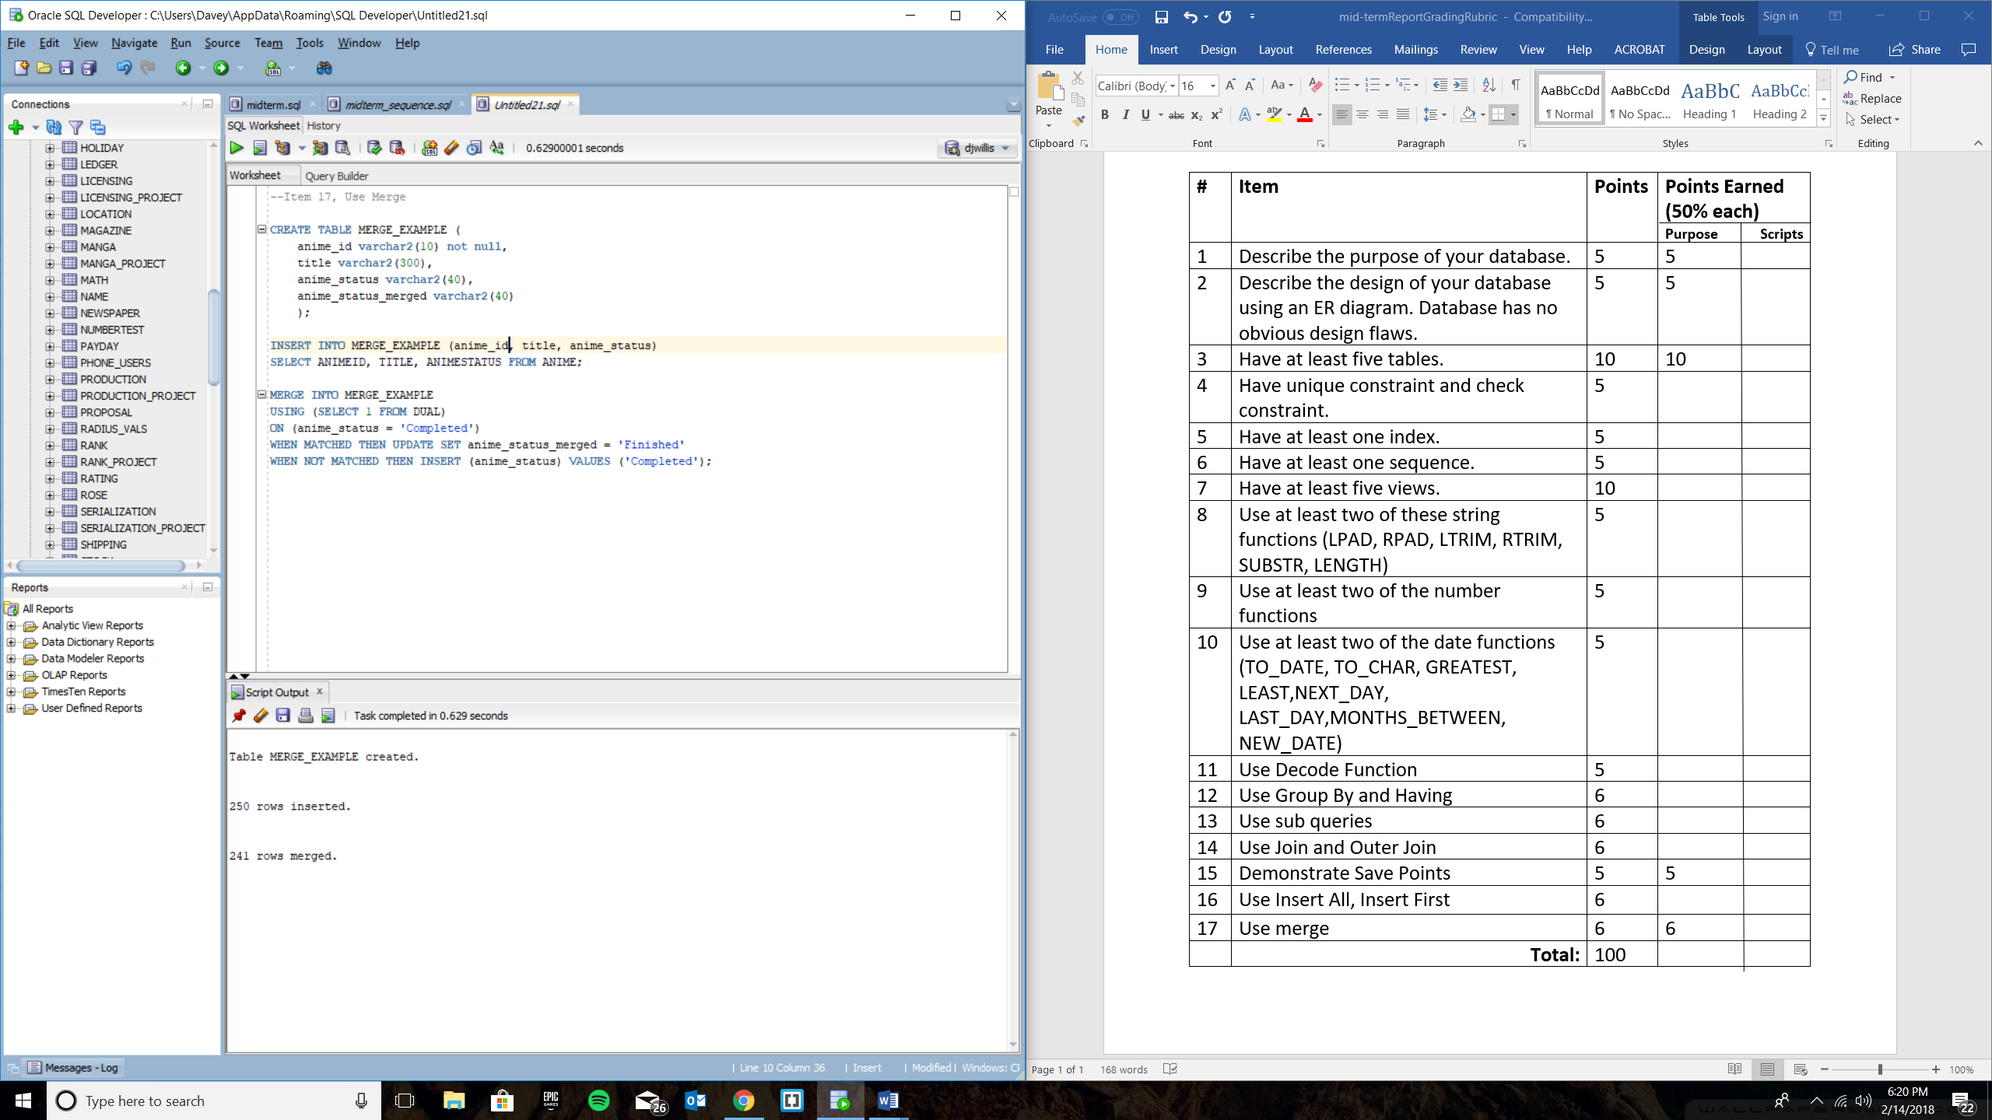

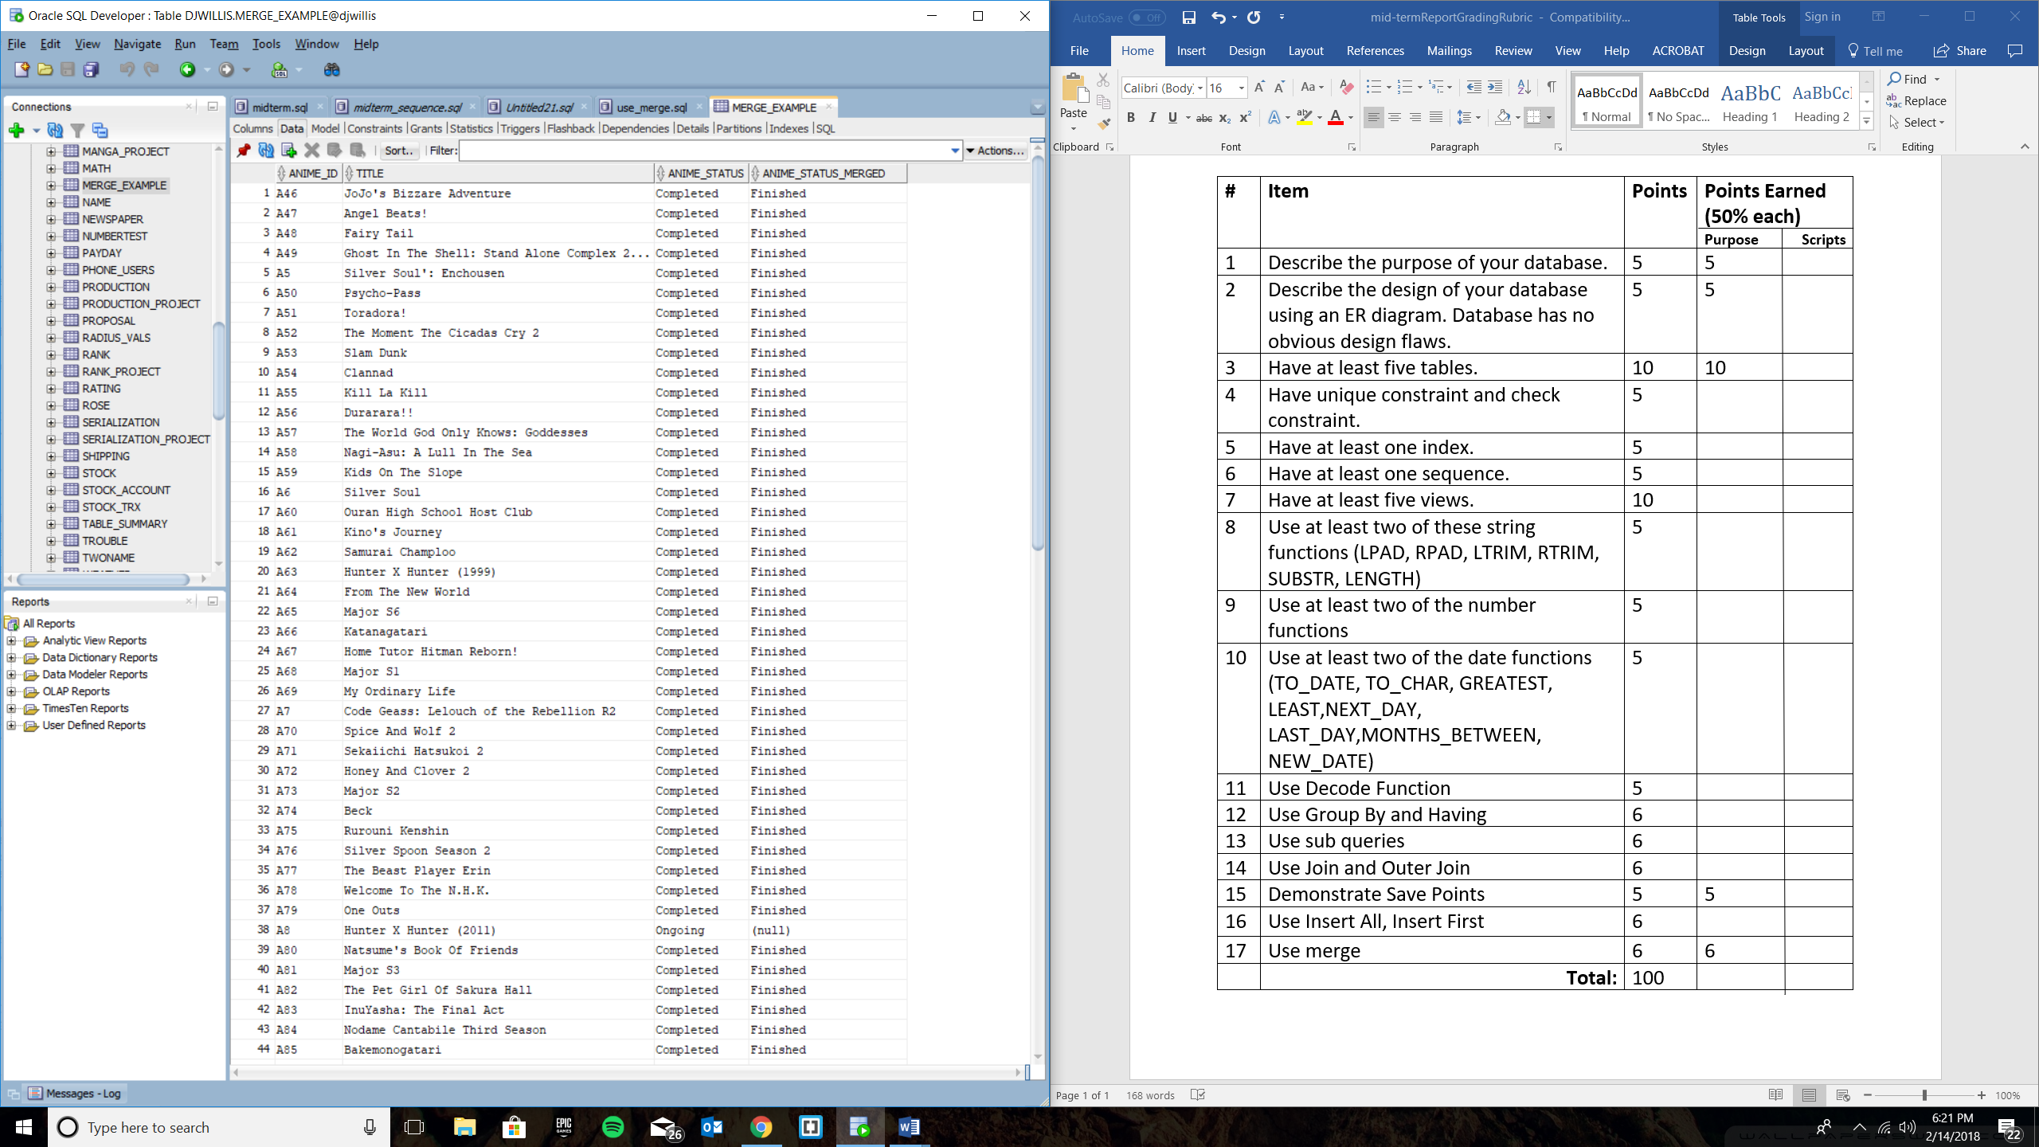

**Item 9**

--Item 9, Two number functions

CREATE VIEW MASTERPIECE_SHOWS AS

SELECT anime_id, members_voted, ranked, ROUND(SCORE) AS ROUNDED_SCORE, TRUNC(SCORE, 1) AS TRUNC_SCORE

FROM RANK_PROJECT

WHERE SCORE > 9;

--Item 15, Demonstrate Save Points

savepoint num_func_save_point_example;

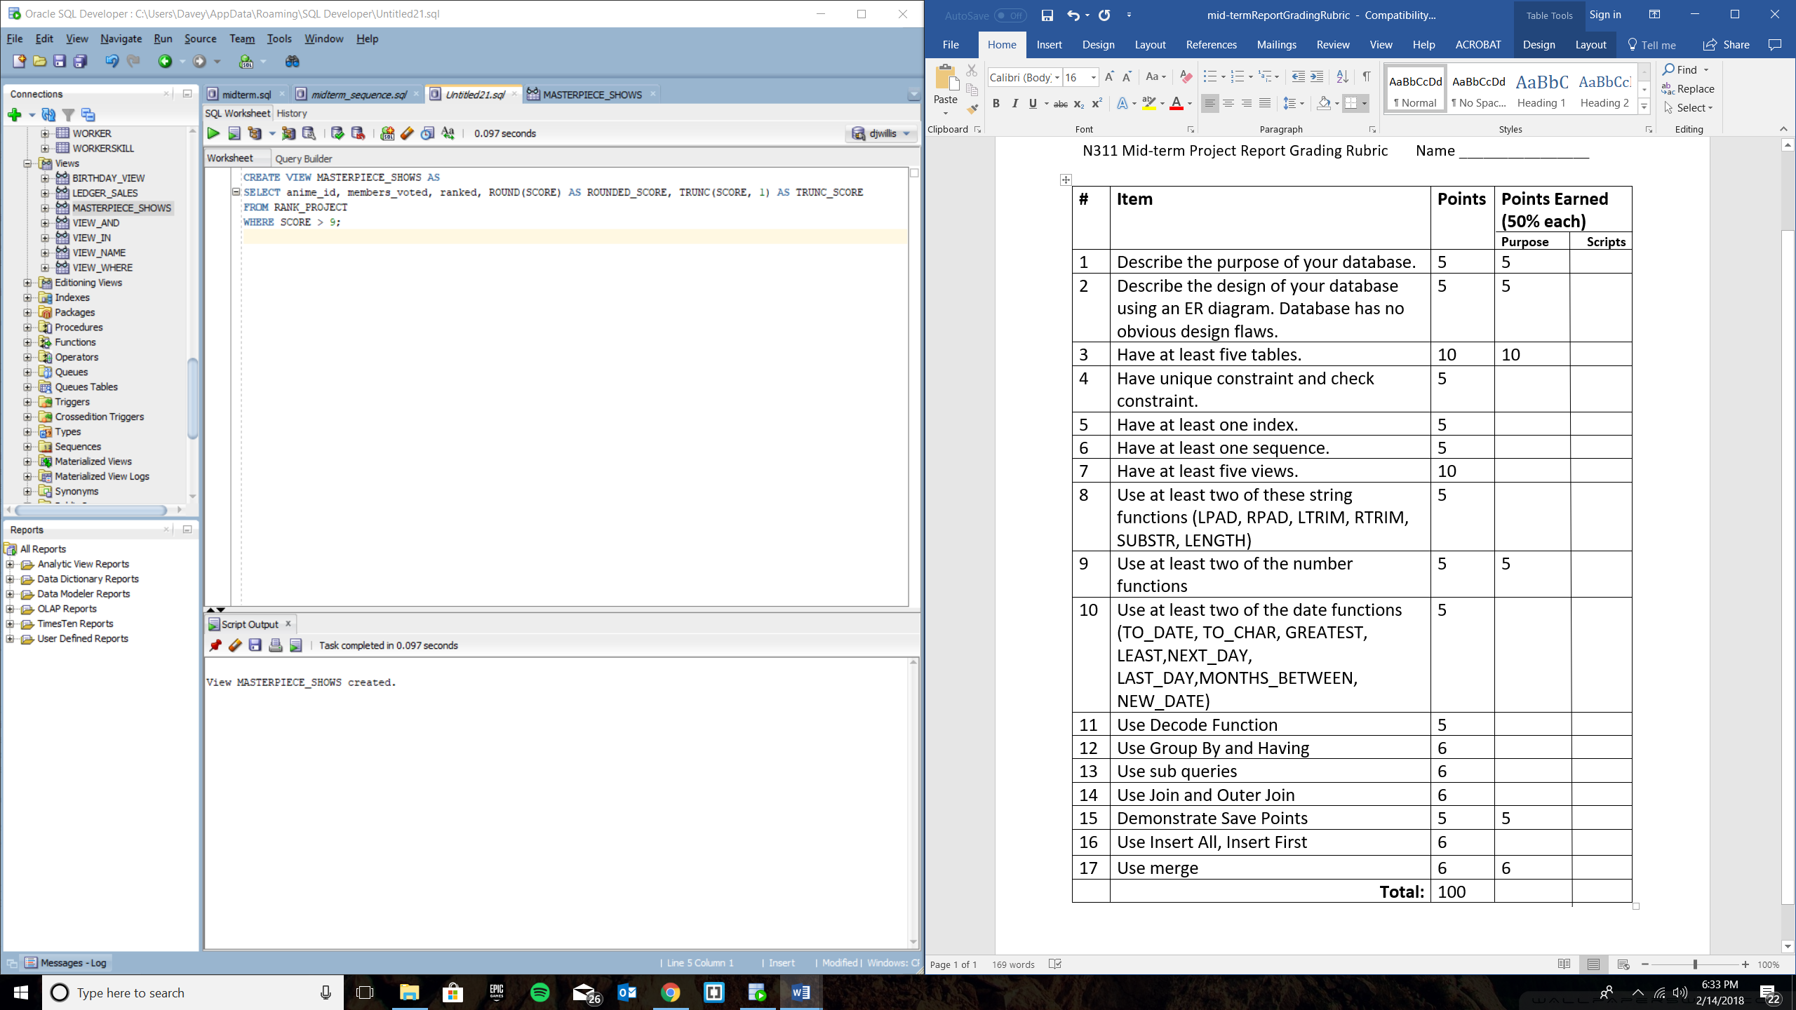

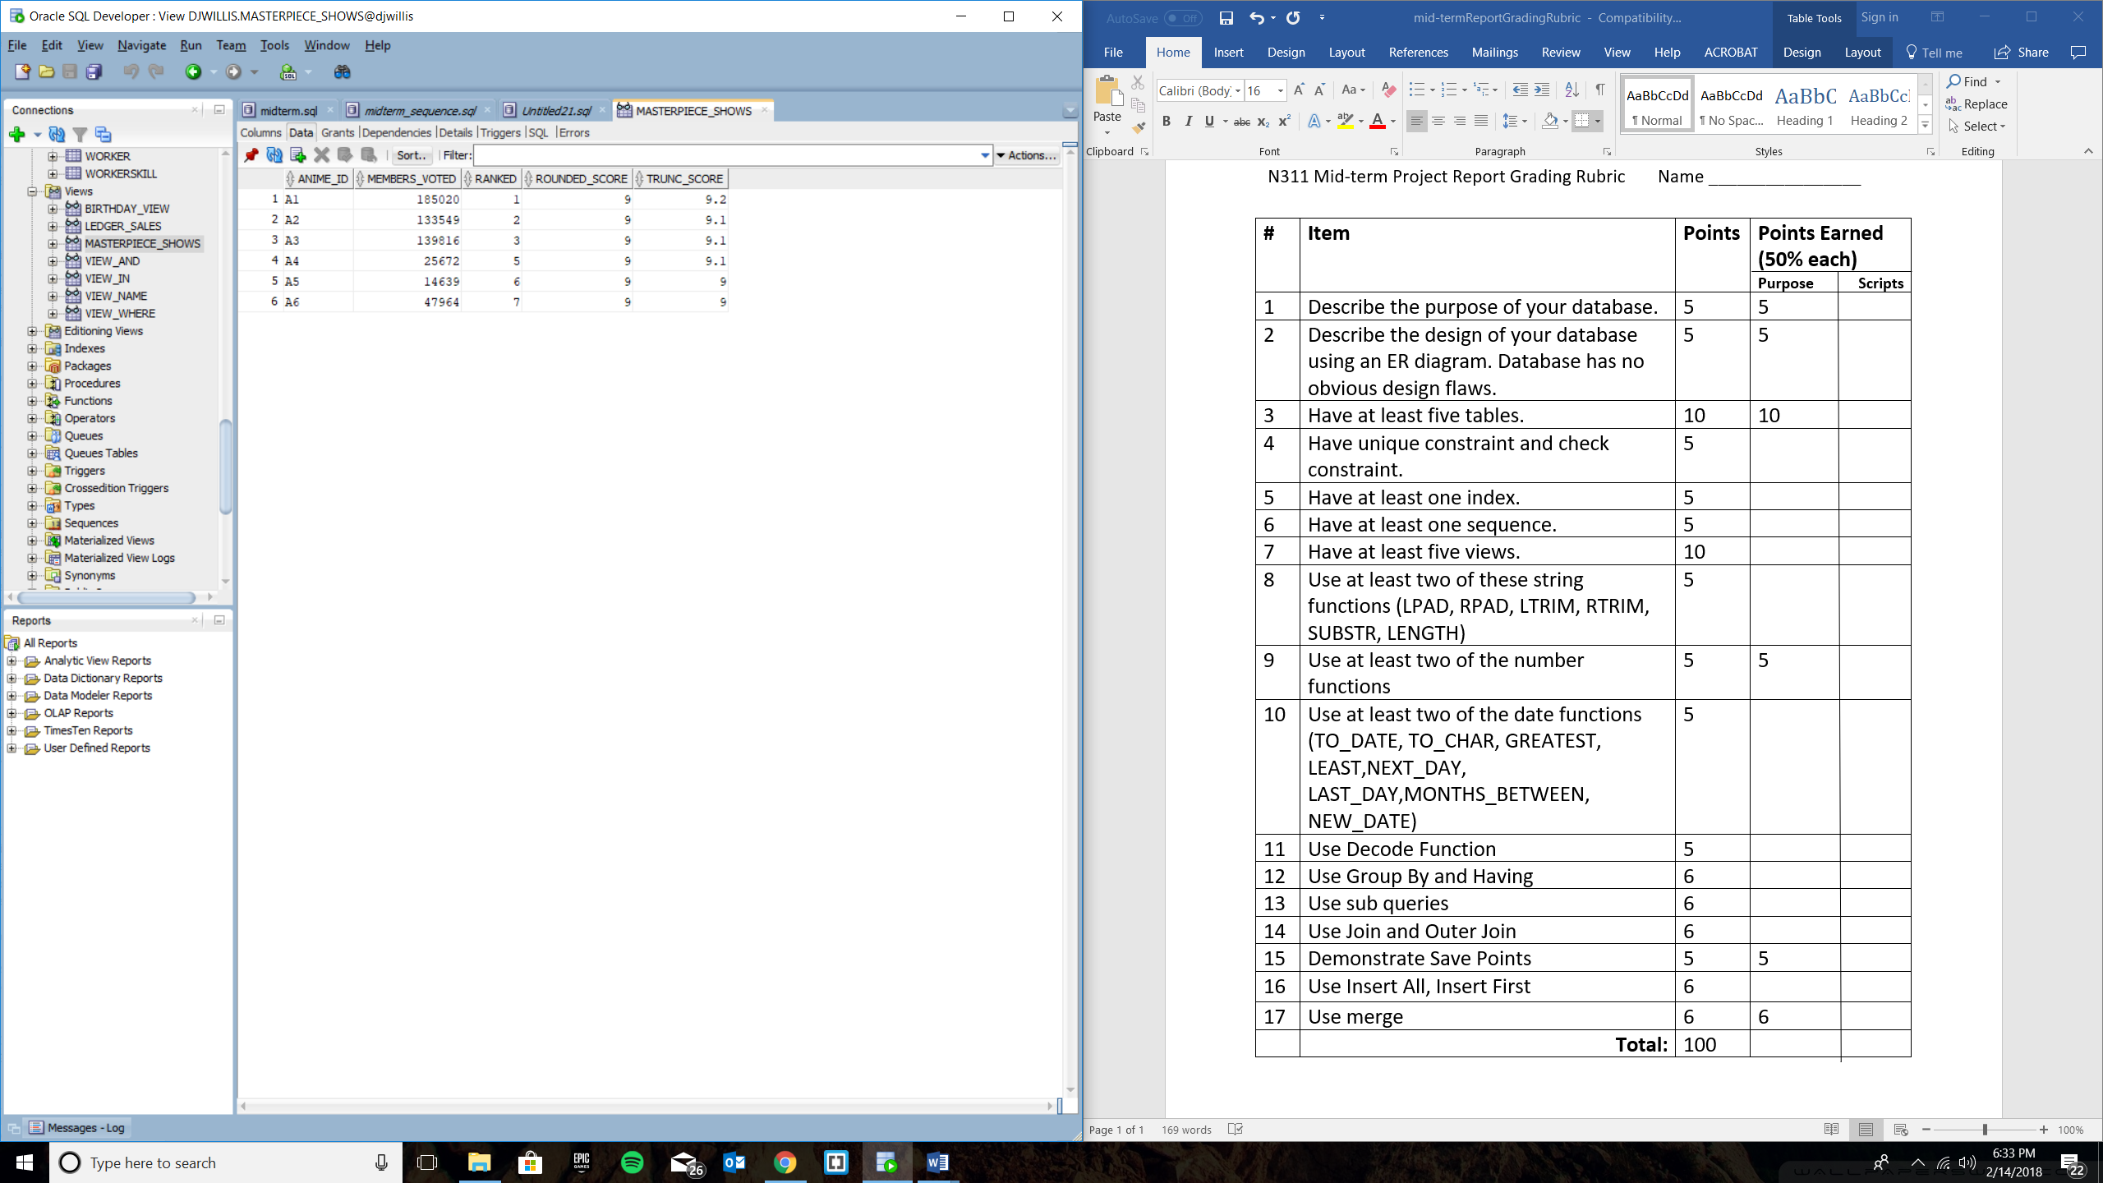

**Item 6, Have at least one sequence**

**--Items 6, Have at least one sequence**

**CREATE TABLE SEQUENCE_EXAMPLE (**

**id_number int not null,**

**anime_id VARCHAR2(10),**

**licensed_by VARCHAR2(80),**

**episodes NUMBER,**

**first_aired DATE,**

**last_aired DATE**

**);**

**CREATE SEQUENCE INCREMENT_SEQUENCE_EX**

**MINVALUE 1**

**START WITH 1**

**INCREMENT BY 1**

**CACHE 250**

**ORDER**

**NOCYCLE;**

**DECLARE**

**i int := 1;**

**BEGIN**

**FOR i IN 1 .. 250 LOOP**

**INSERT INTO SEQUENCE_EXAMPLE(id_number, anime_id, licensed_by, episodes, first_aired, last_aired)**

**SELECT INCREMENT_SEQUENCE_EX.nextval, anime_id, licensed_by, episodes, first_aired, last_aired**

**FROM (SELECT anime_id, licensed_by, episodes, first_aired, last_aired FROM LICENSING_PROJECT);**

**END LOOP;**

**END;**

**--Item 15, Demonstrate Save Points**

**savepoint sequence_save_point_example;**

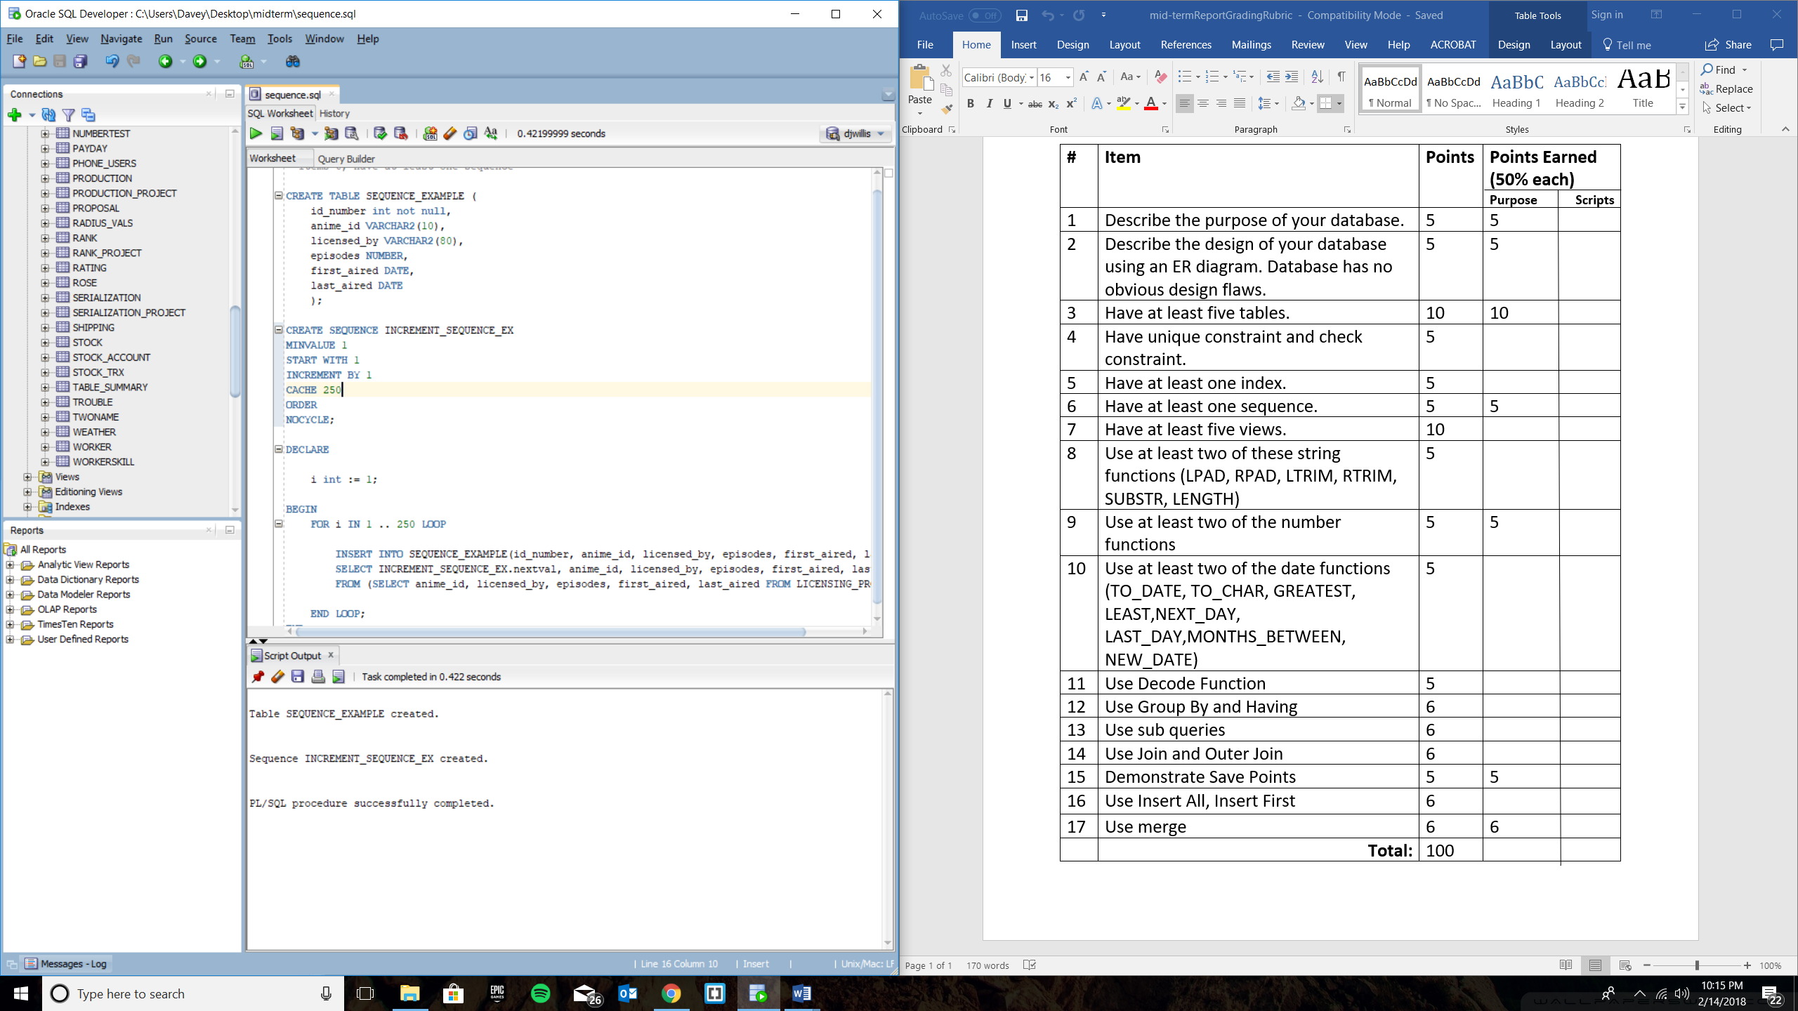

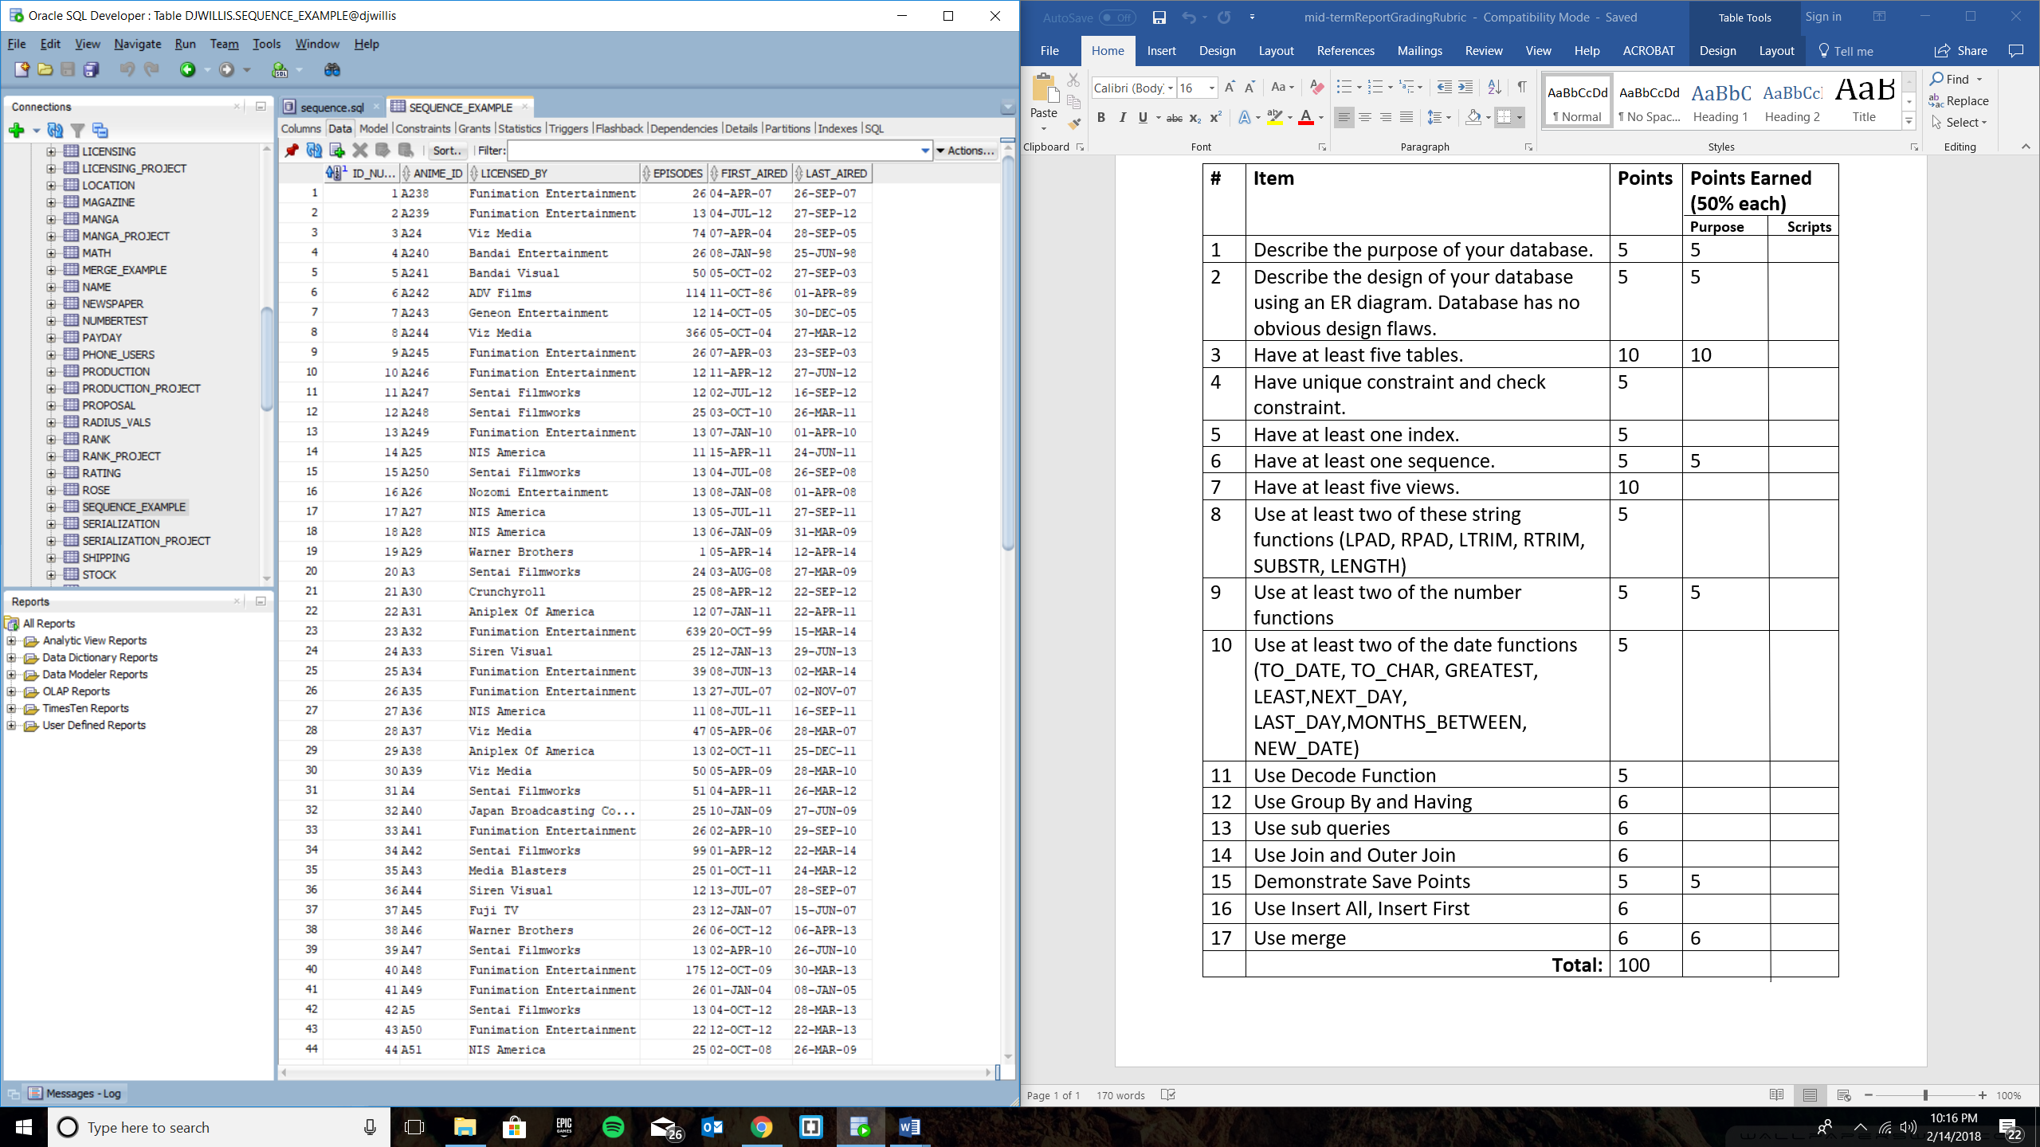

**Item 16, Use Insert All**

--Item 16, Use Insert All

CREATE TABLE INSERT_ALL_EX (

anime_id VARCHAR2(10),

members_voted NUMBER,

ranked NUMBER,

score NUMBER

);

CREATE TABLE NINE_SCORE AS

SELECT * FROM INSERT_ALL_EX;

CREATE TABLE EIGHT_SCORE AS

SELECT * FROM INSERT_ALL_EX;

CREATE TABLE SEVEN_SCORE AS

SELECT * FROM INSERT_ALL_EX;

INSERT ALL

WHEN score > 8.99 THEN

INTO NINE_SCORE

WHEN score > 7.99 AND score < 9 THEN

INTO EIGHT_SCORE

WHEN score < 8 THEN

INTO SEVEN_SCORE

SELECT anime_id, members_voted, ranked, score

FROM RANK_PROJECT;

--Item 15, Demonstrate Save Points

savepoint insert_all_example;

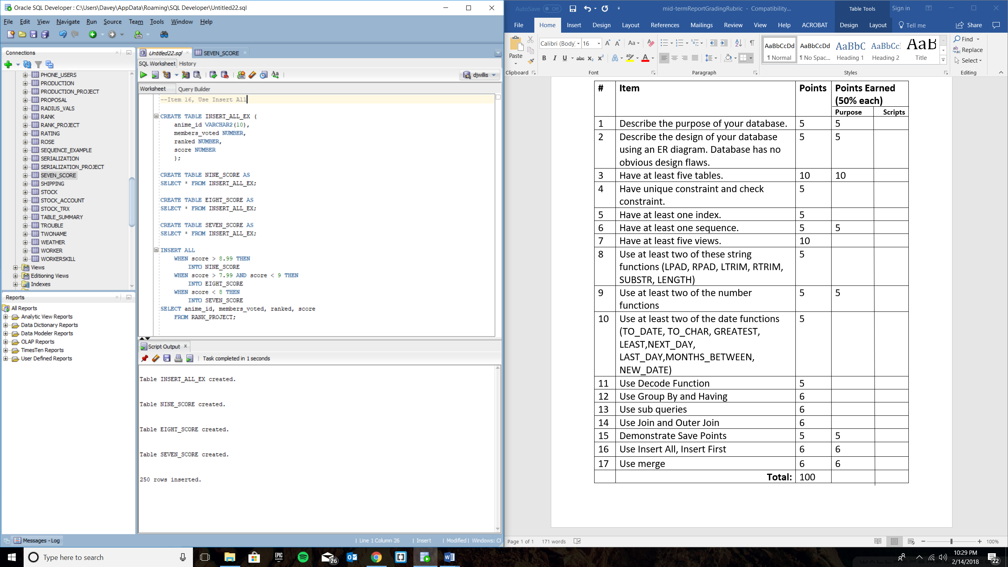

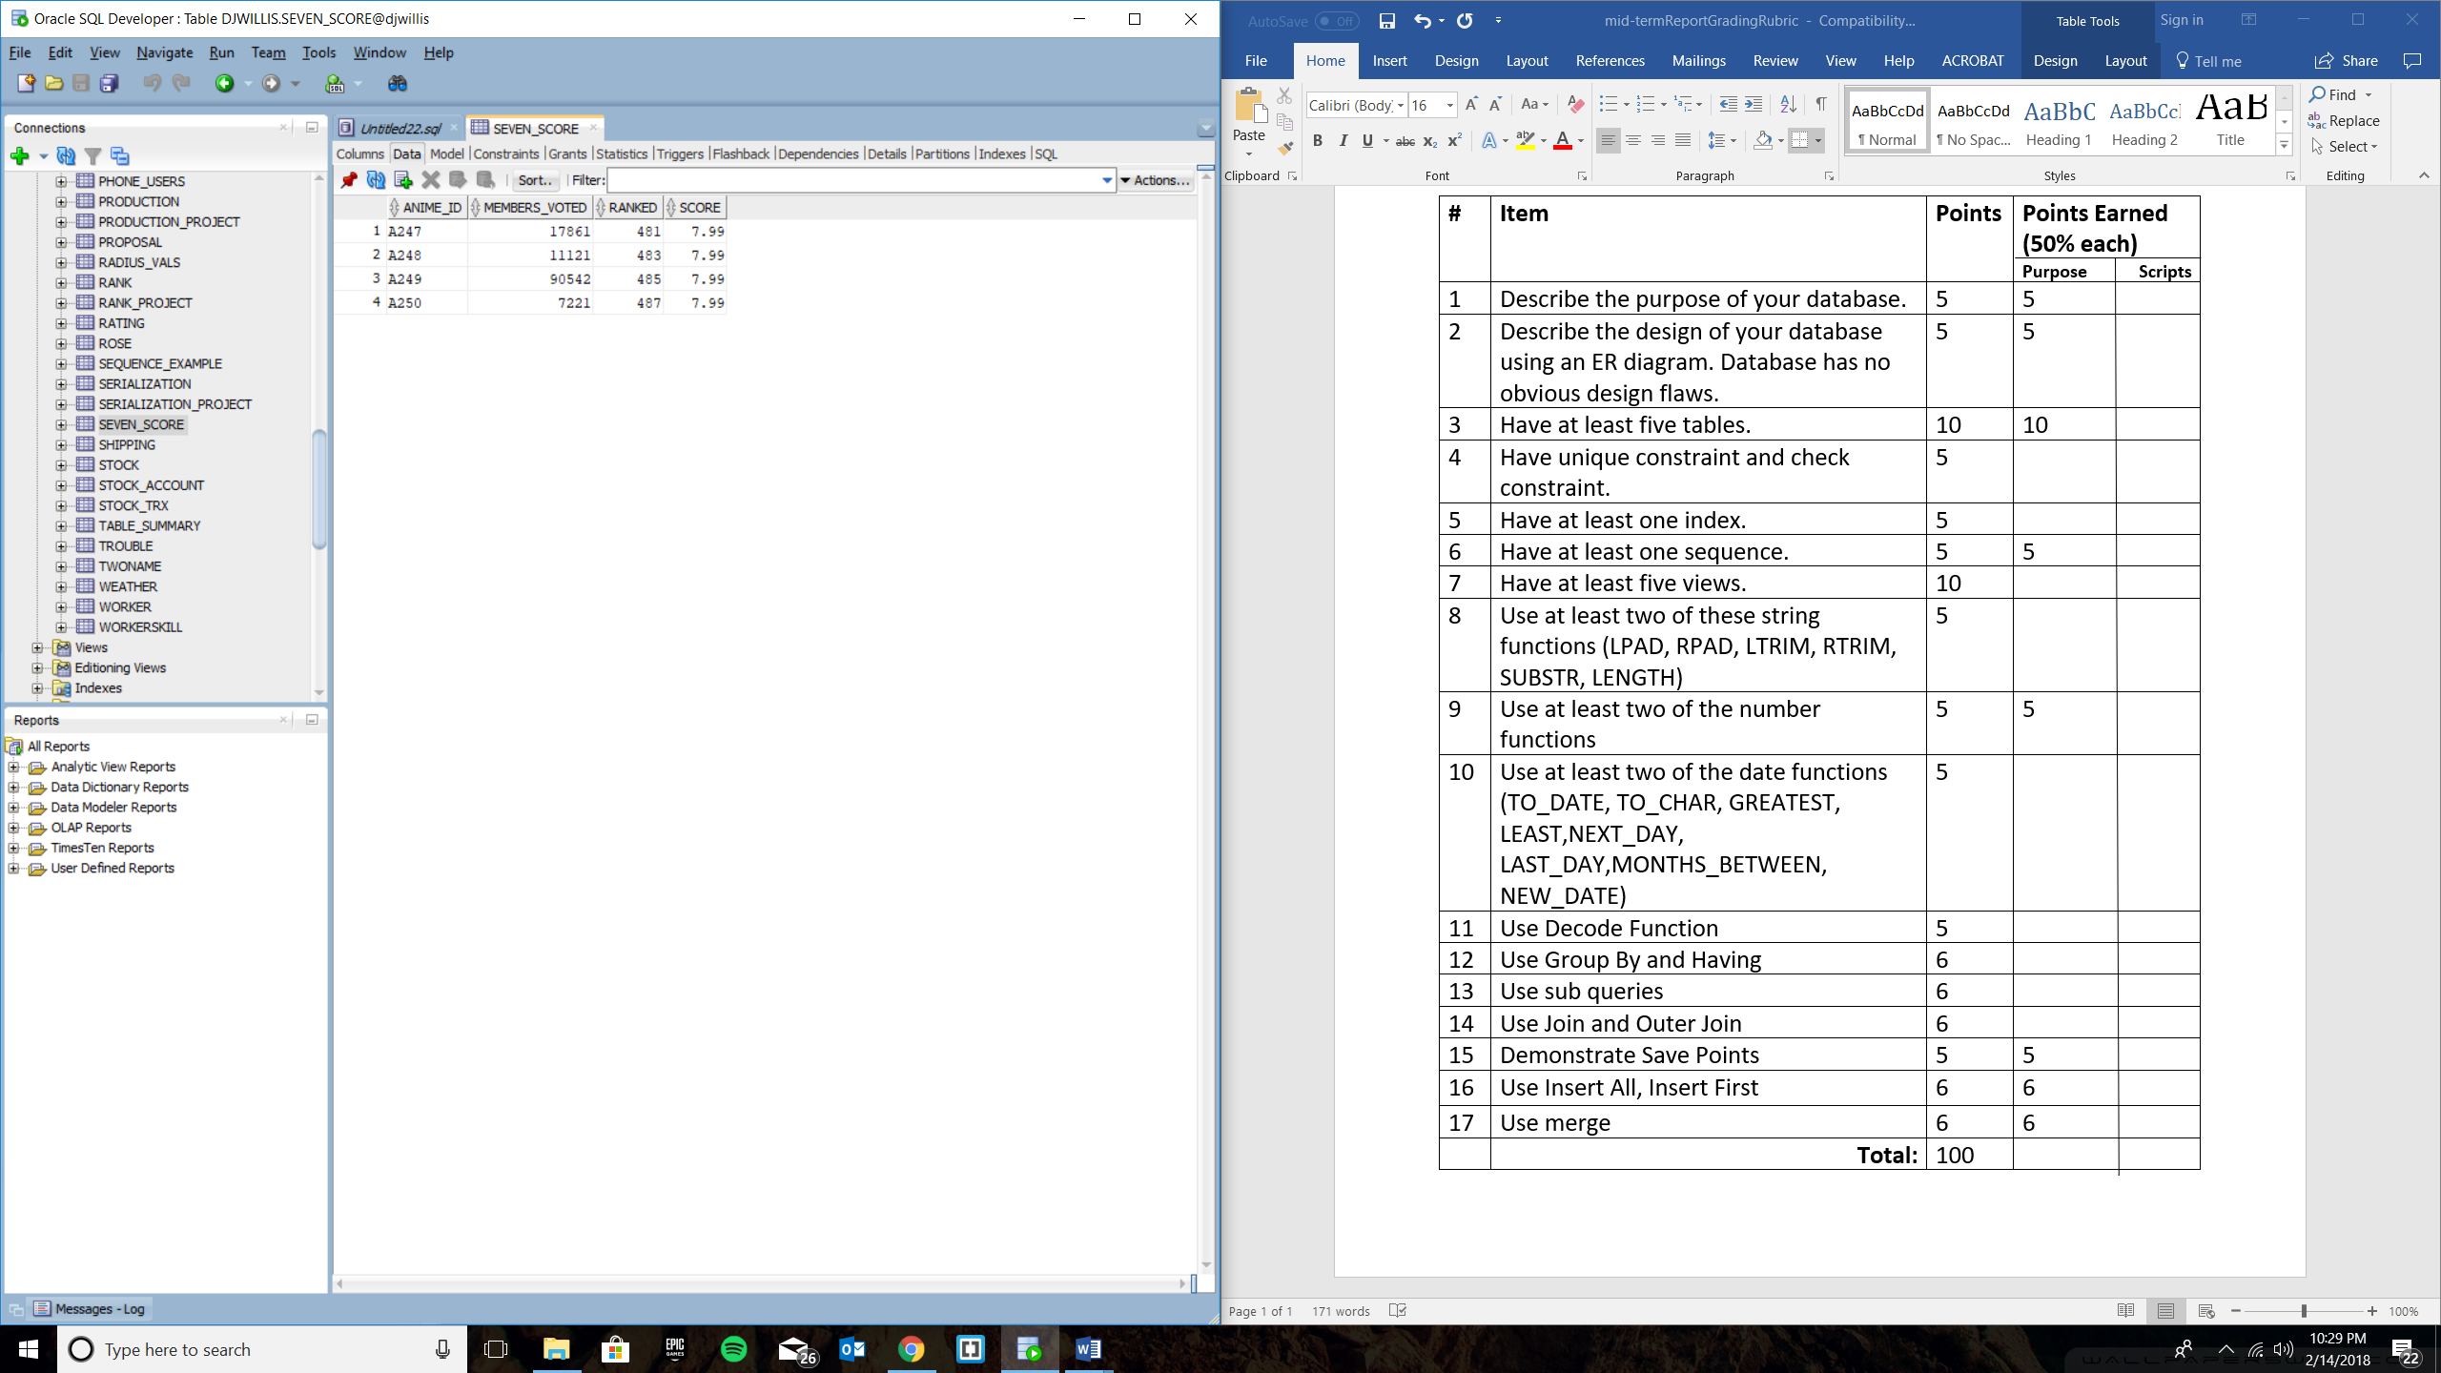

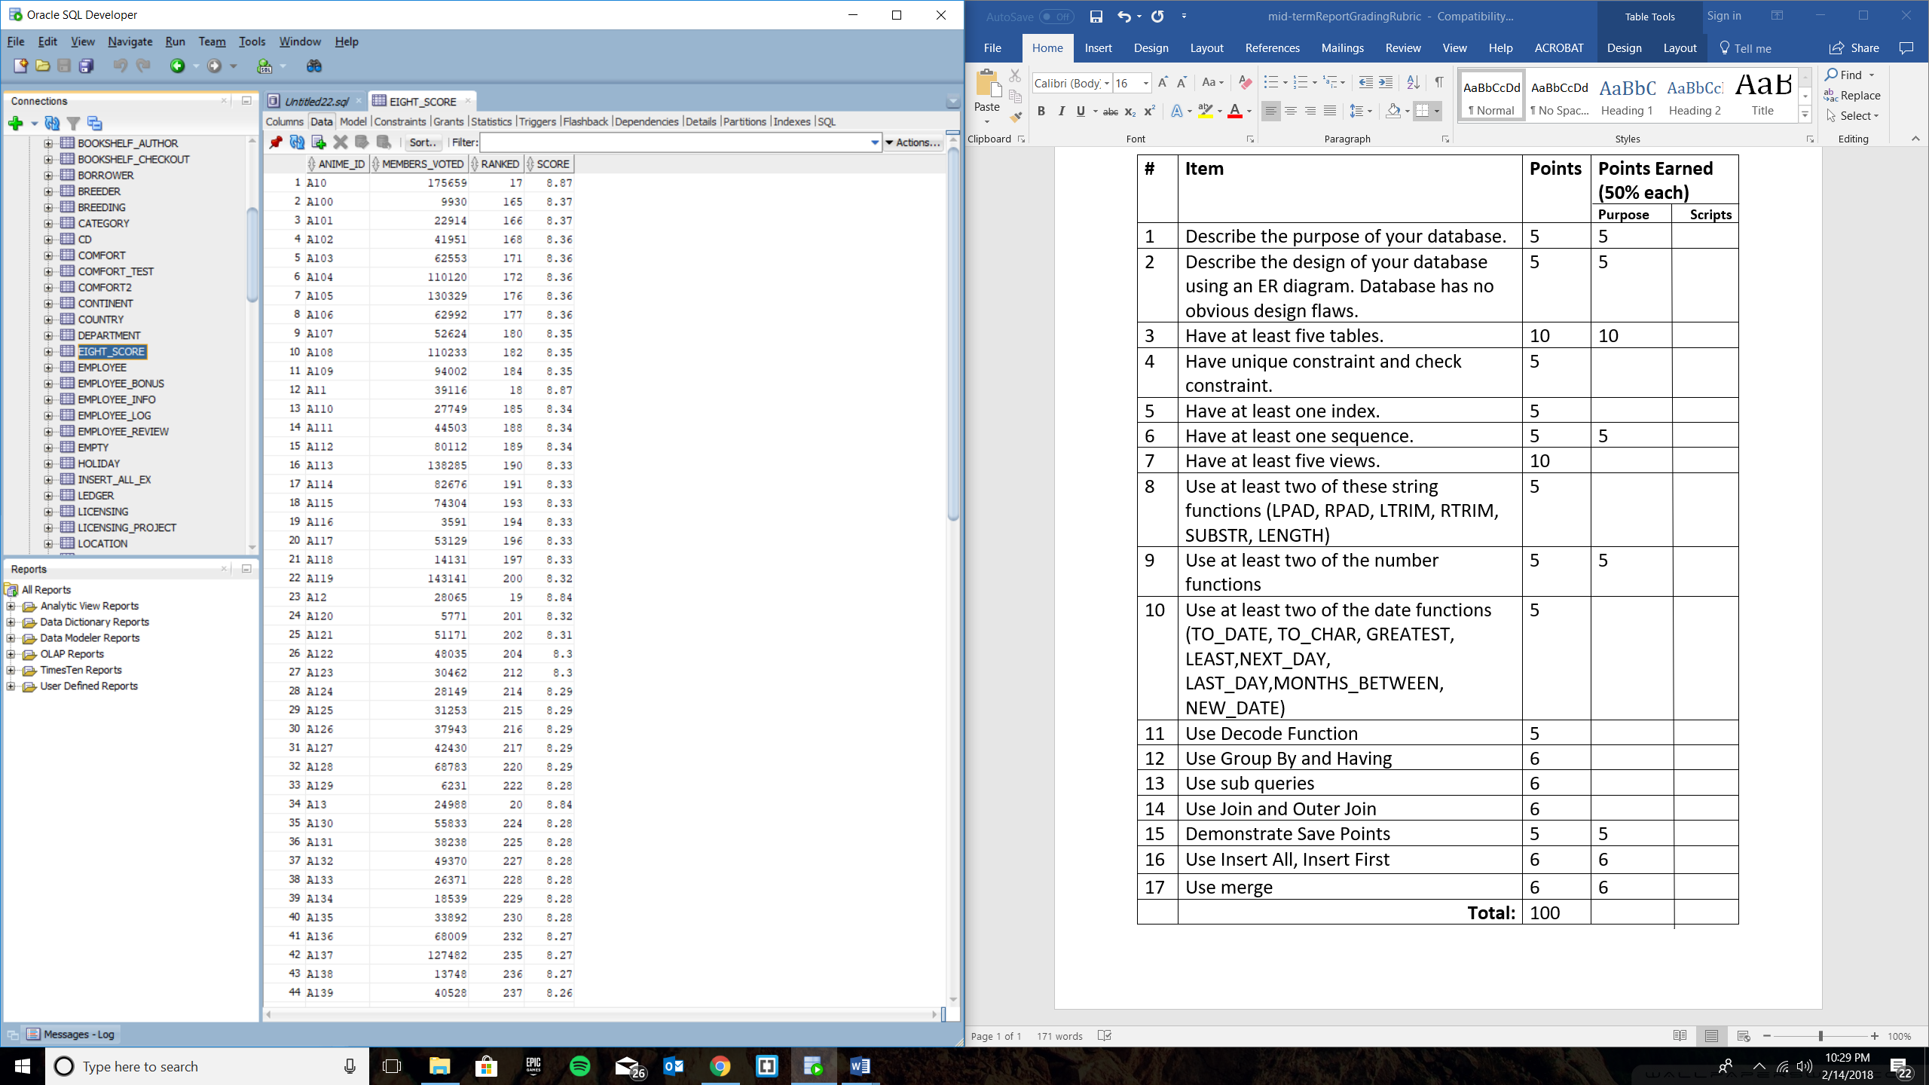

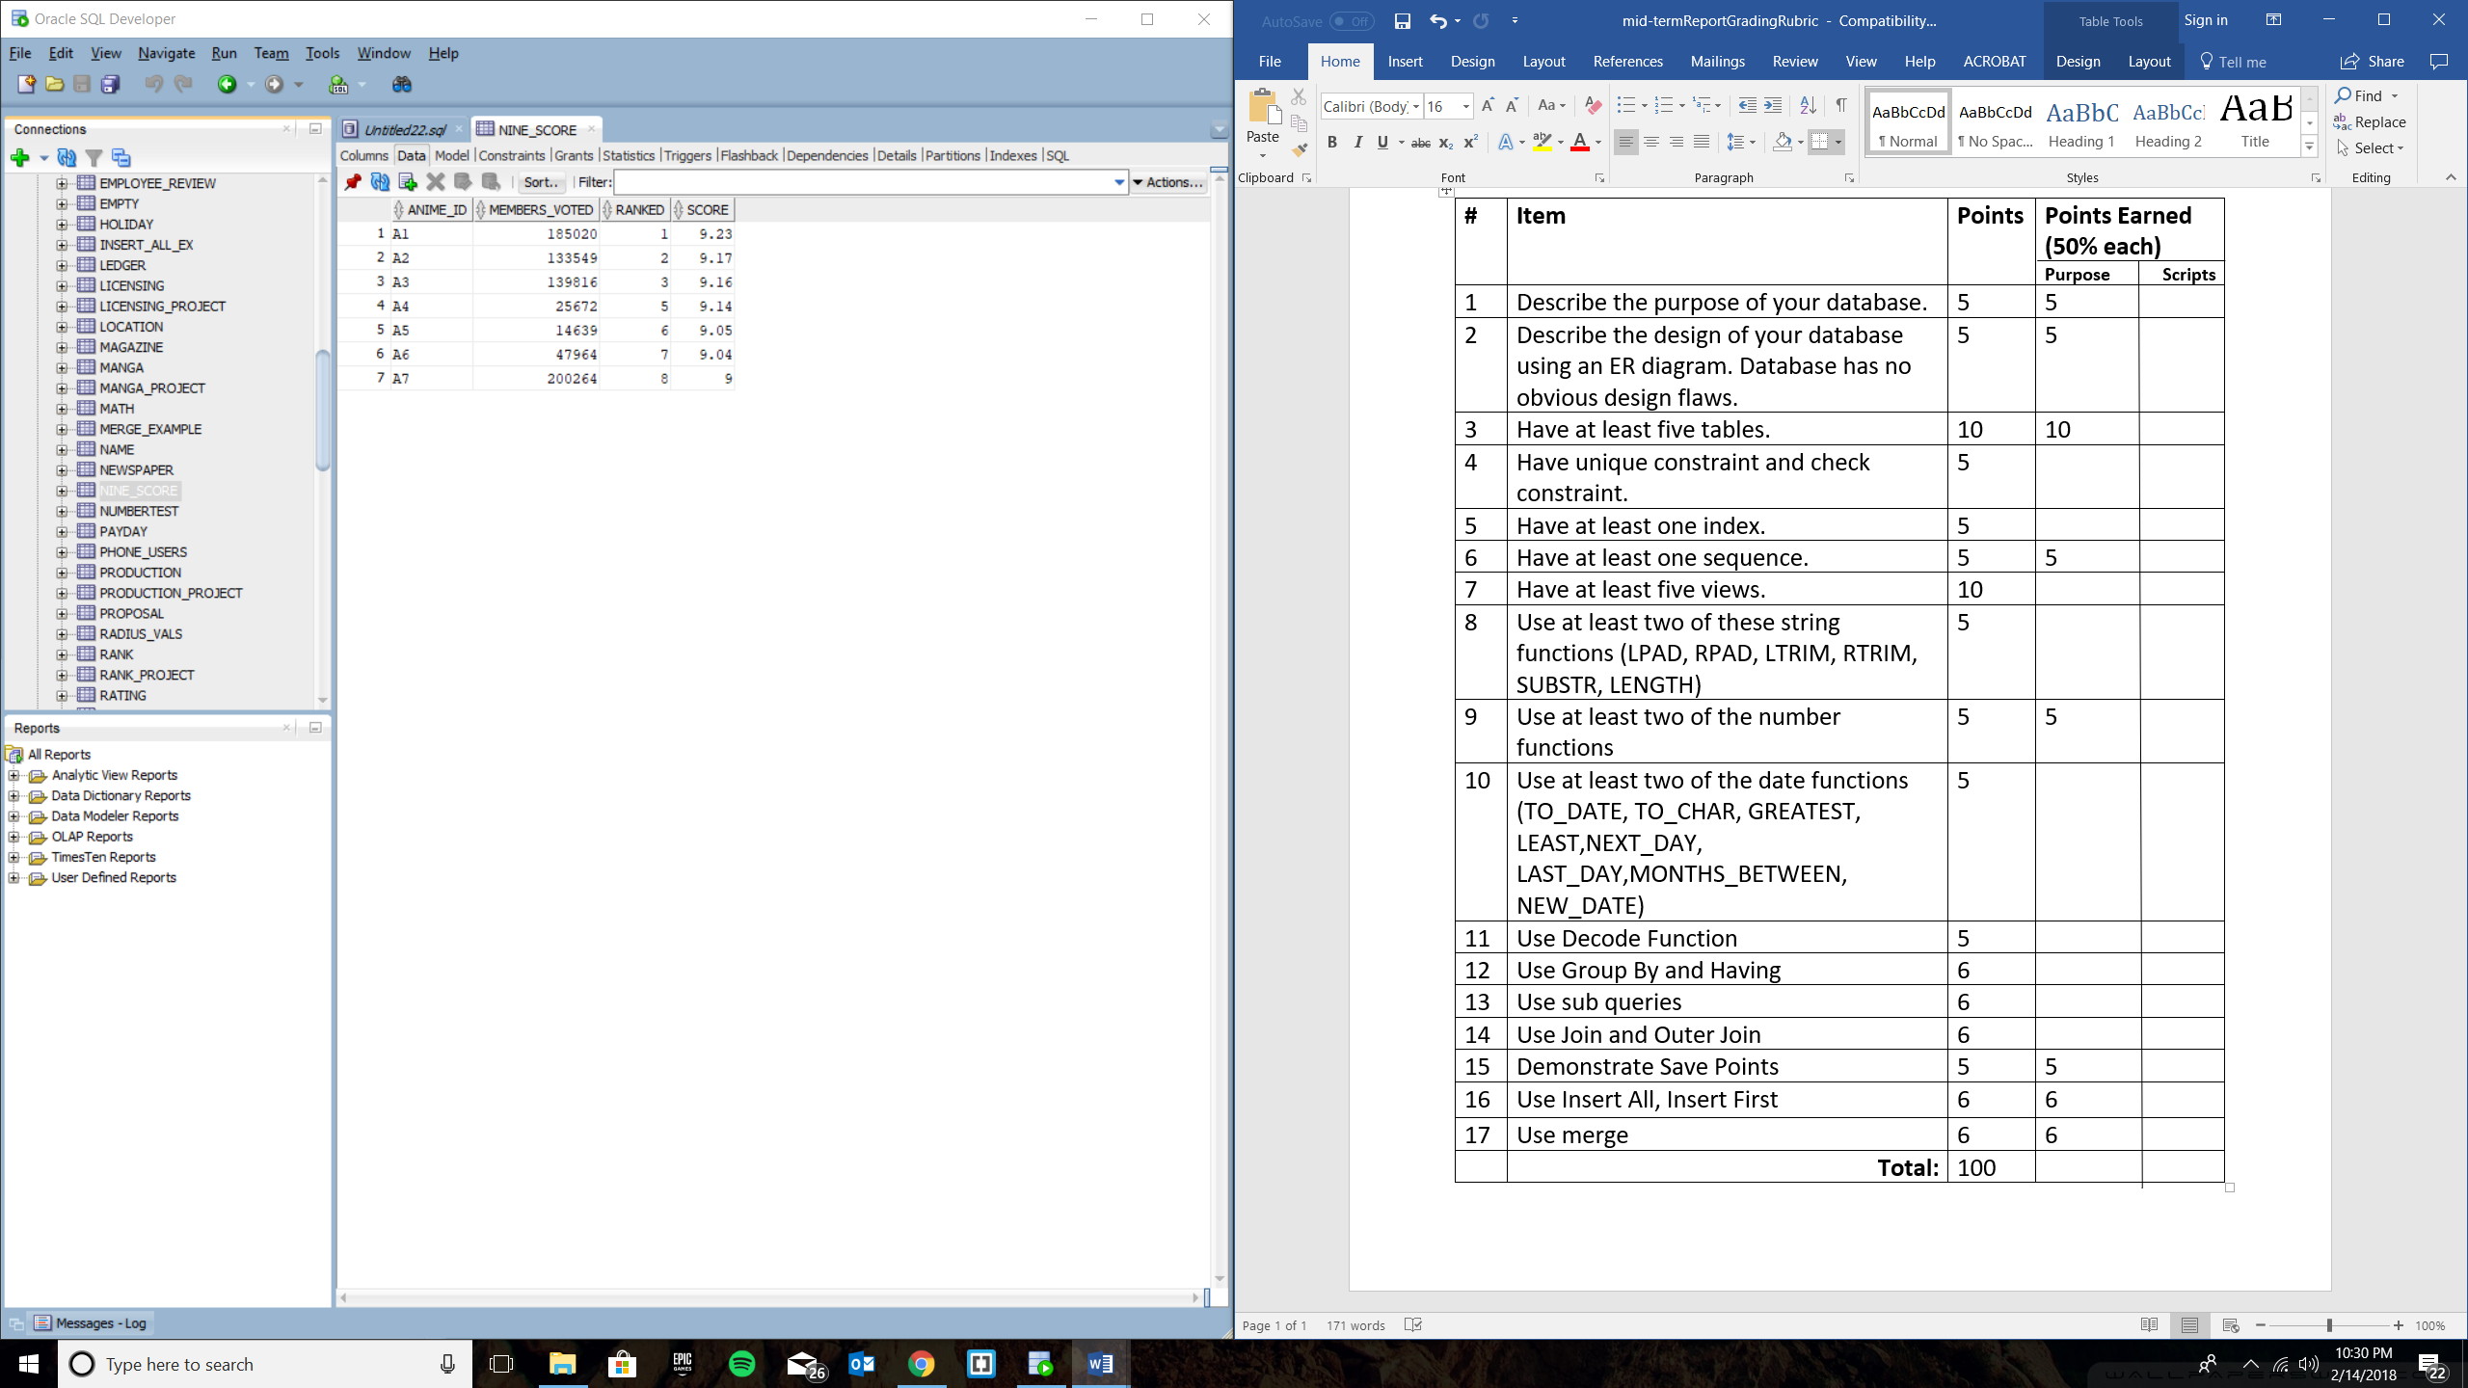

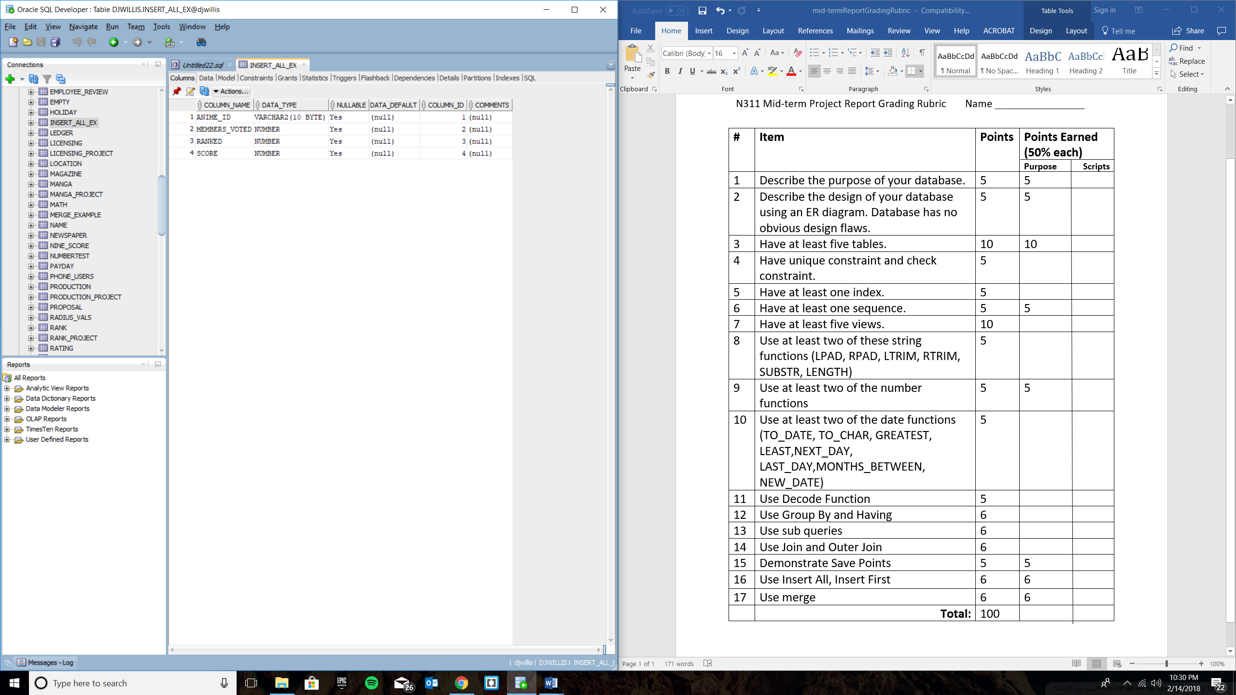

**--Item 7, have at least five views**

**--Show masterpiece shows, meaning shows that achieve a score above 9.00**

**CREATE OR REPLACE VIEW MASTERPIECE_SHOWS AS**

**SELECT anime_id, members_voted, ranked, ROUND(SCORE) AS ROUNDED_SCORE, TRUNC(SCORE, 1) AS TRUNC_SCORE**

**FROM RANK_PROJECT**

**WHERE SCORE > 9;**

**--List ongoing shows within anime database**

**CREATE OR REPLACE VIEW ONGOING_SHOWS AS**

**SELECT anime_id, title, anime_status, main_genre, rating**

**FROM ANIME_PROJECT**

**WHERE anime_status = 'Ongoing';**

**--Manga Ascending Rank with a Score between 8 to 8.99**

**CREATE OR REPLACE VIEW MANGA_ASC_RANK_SCORE_OF_8 AS**

**SELECT anime_id, members_voted, ranked, score FROM RANK_PROJECT**

**WHERE score like '8.%'**

**ORDER BY score;**

**--Find out which anime ends between 24 and 26 episodes, a typical preference by anime fans**

**CREATE OR REPLACE VIEW TOTAL_EPISODES AS**

**SELECT * FROM LICENSING_PROJECT**

**WHERE episodes between 24 AND 26**

**ORDER BY episodes;**

**--Find out which manga is still ongoing but has more than 30 chapters**

**CREATE OR REPLACE VIEW ONGOING_MANGA_CHAPTERS AS**

**SELECT * FROM MANGA_PROJECT**

**WHERE chapters > 30 AND manga_status = 'Ongoing';**

**--Item 15, Demonstrate Save Points**

**savepoint view_save_point_example;**

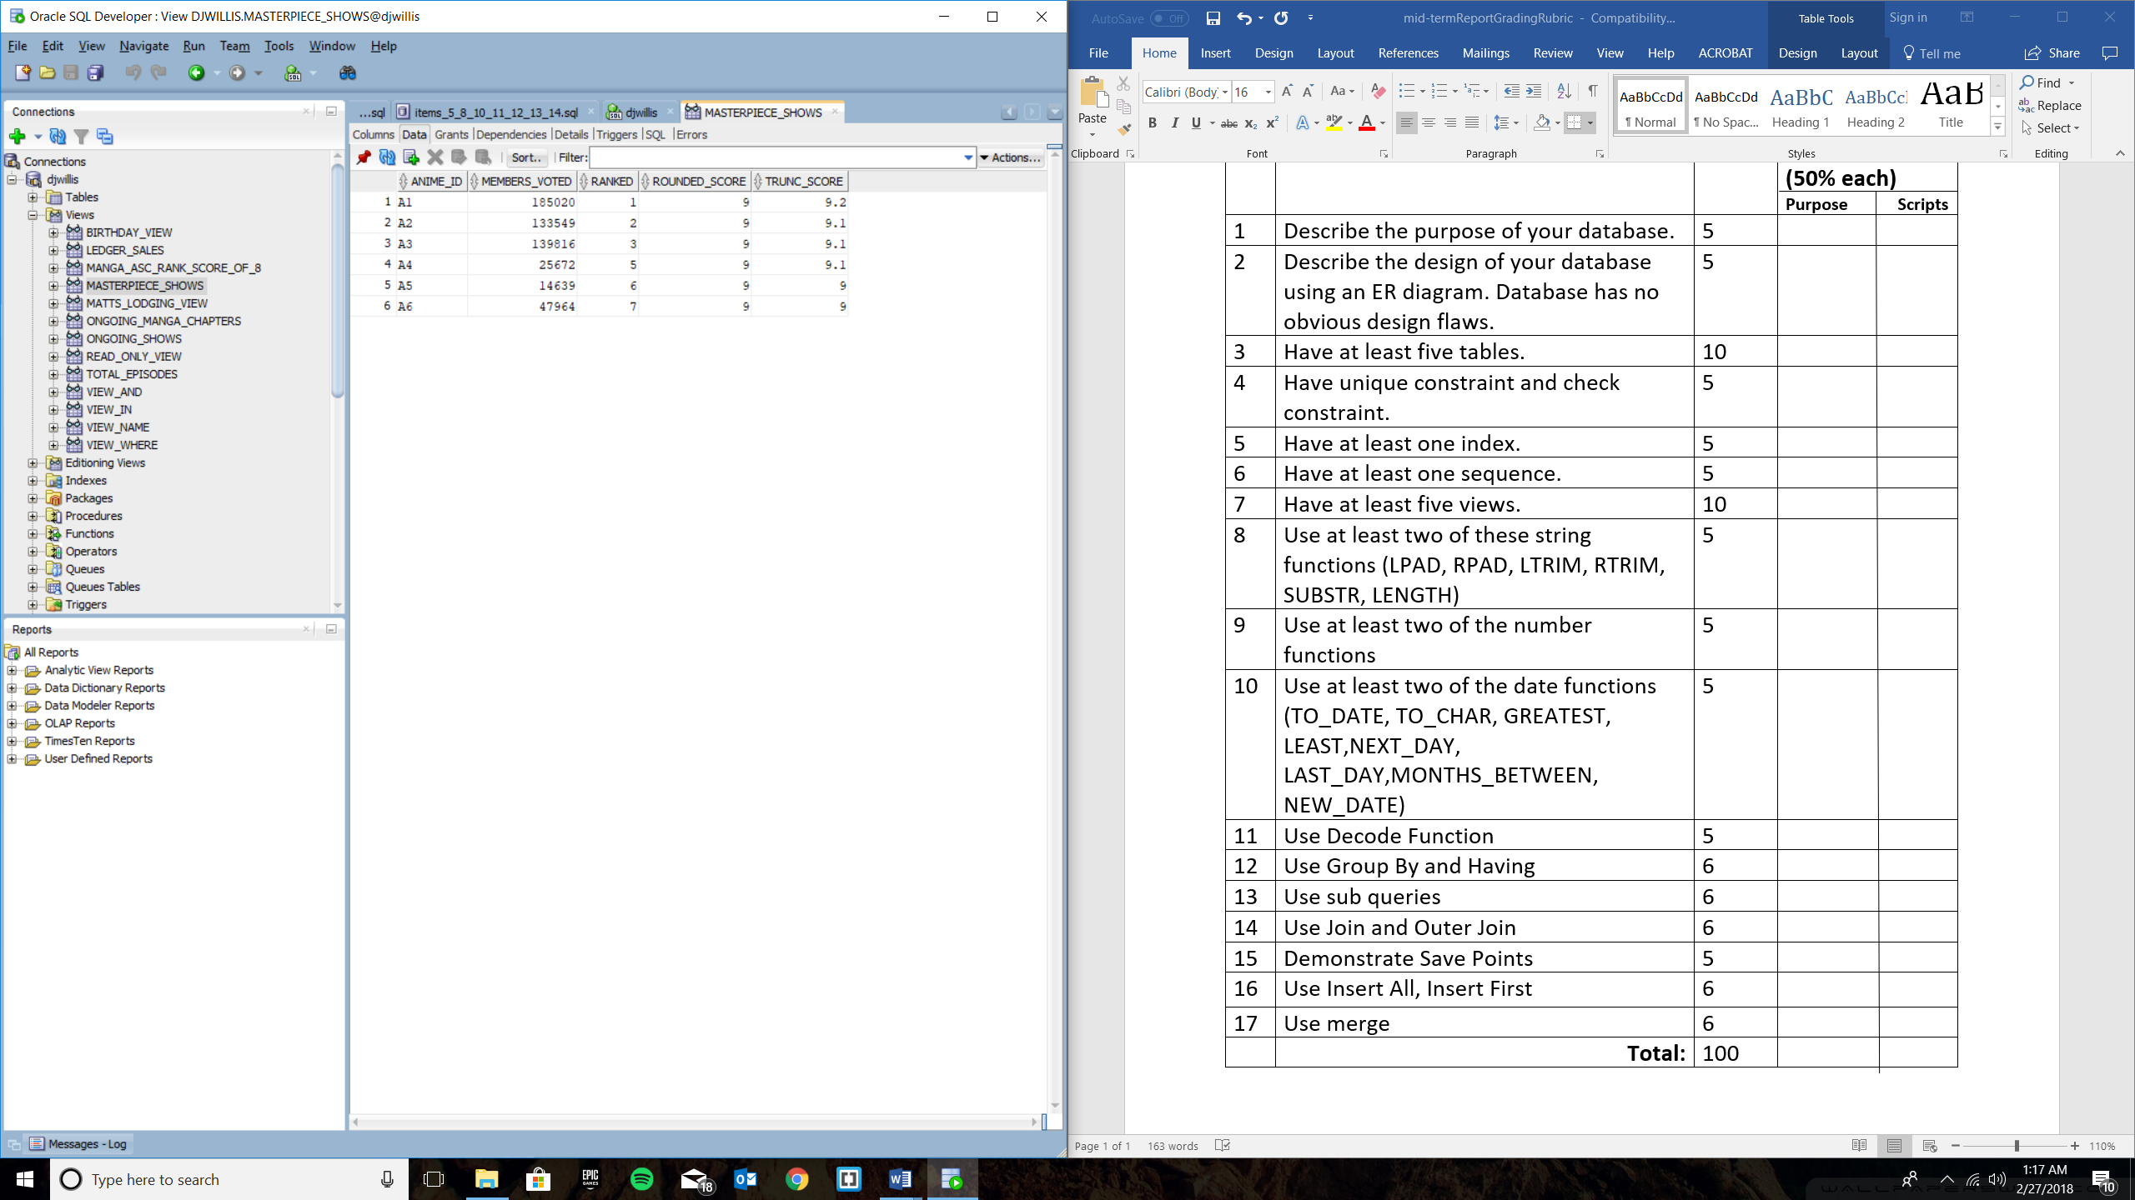

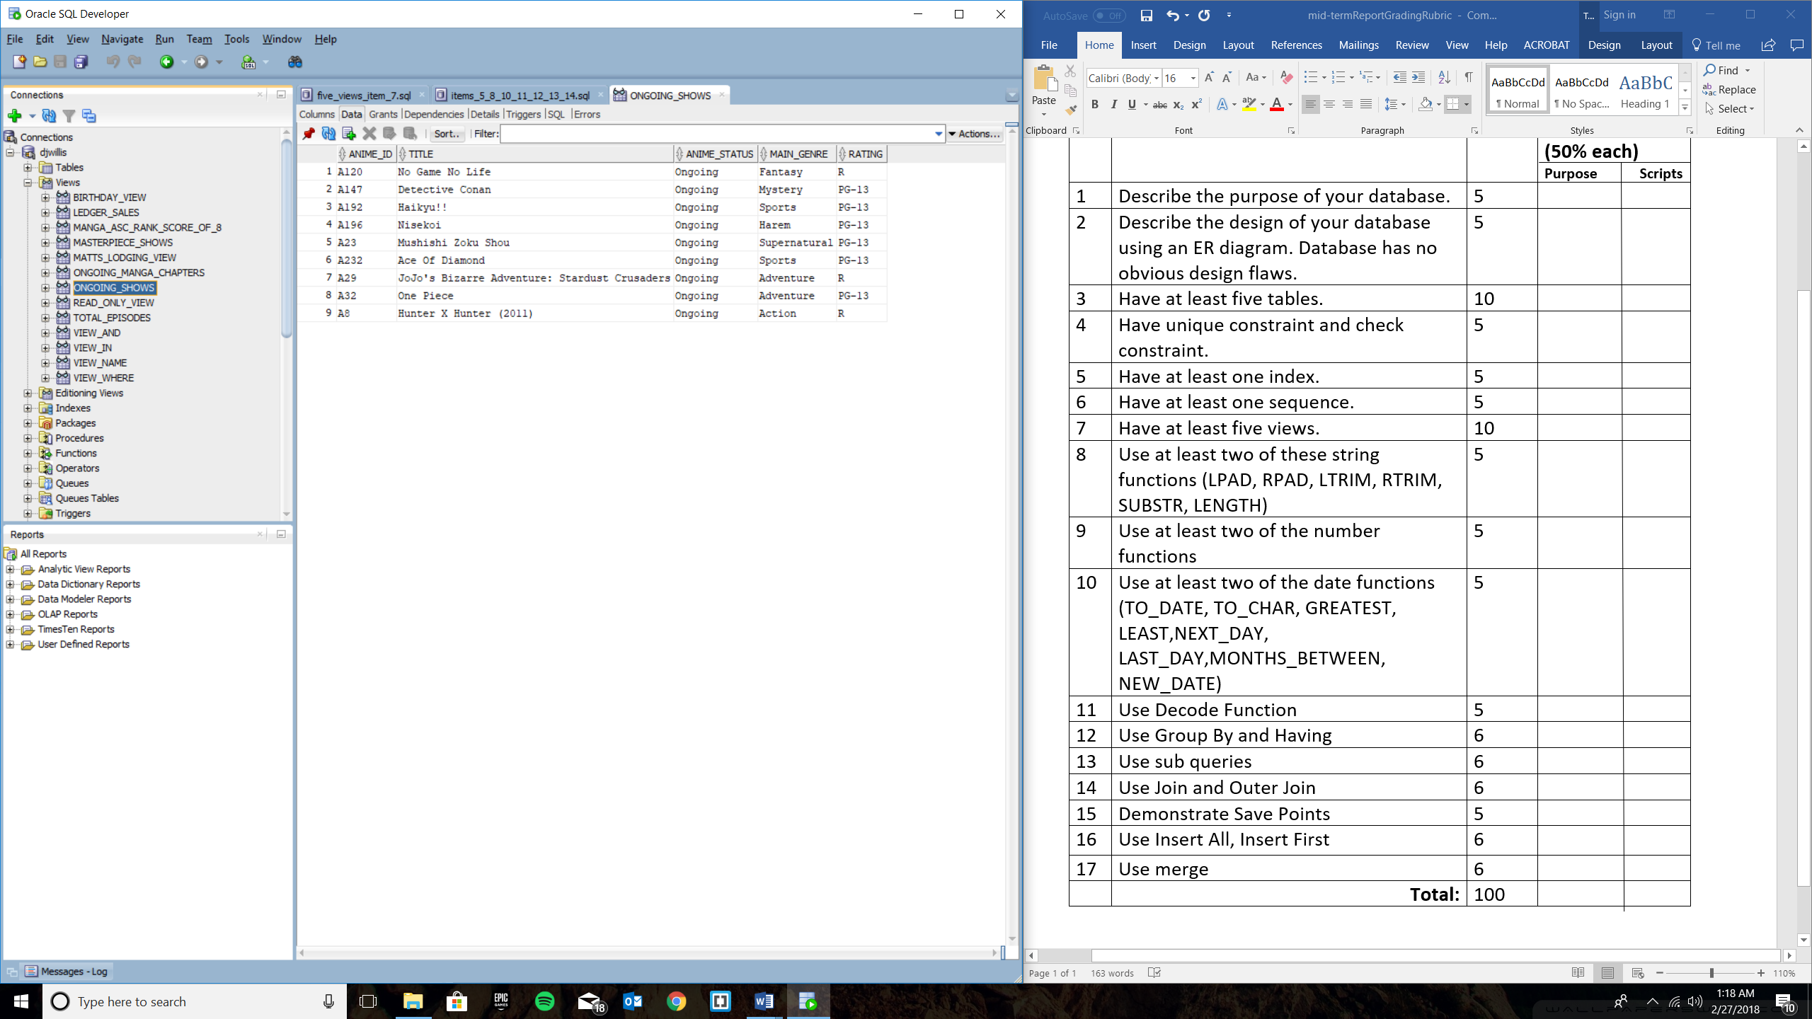

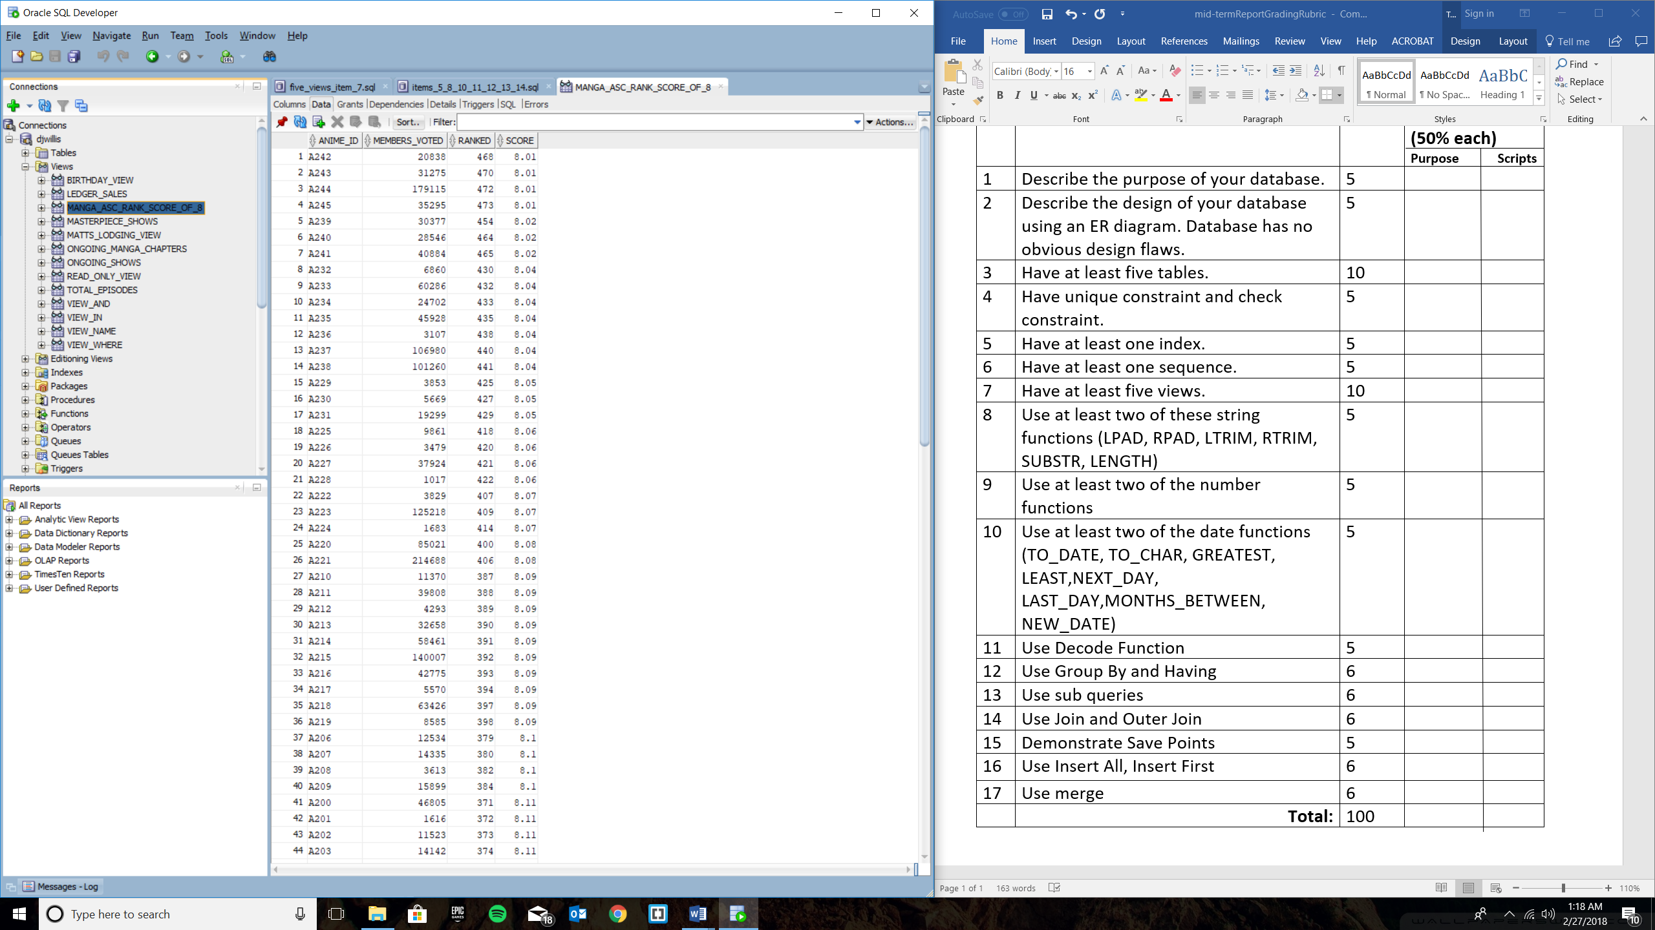

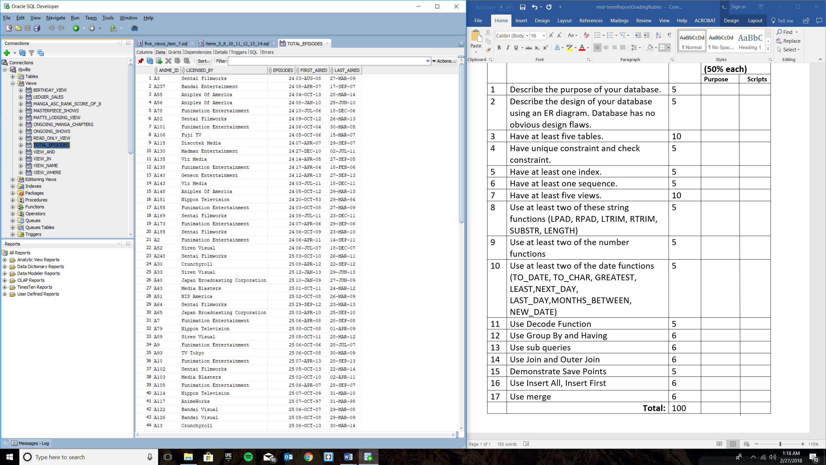

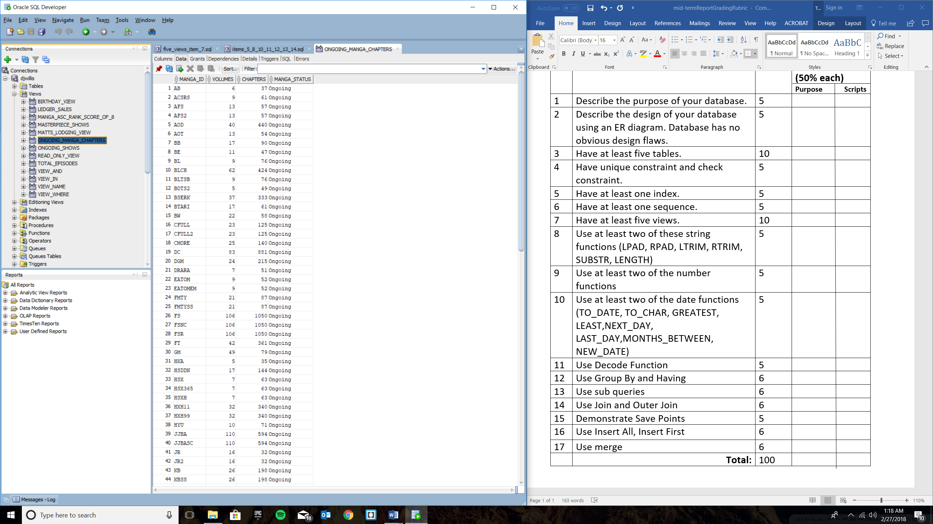

**Items 5, 8, 10, 11, 12, 13, 14**

**--Item 5, Have at least one index**

**CREATE INDEX anime_table_index**

**ON ANIME_PROJECT(anime_id, title, anime_status, main_genre, rating, manga_id);**

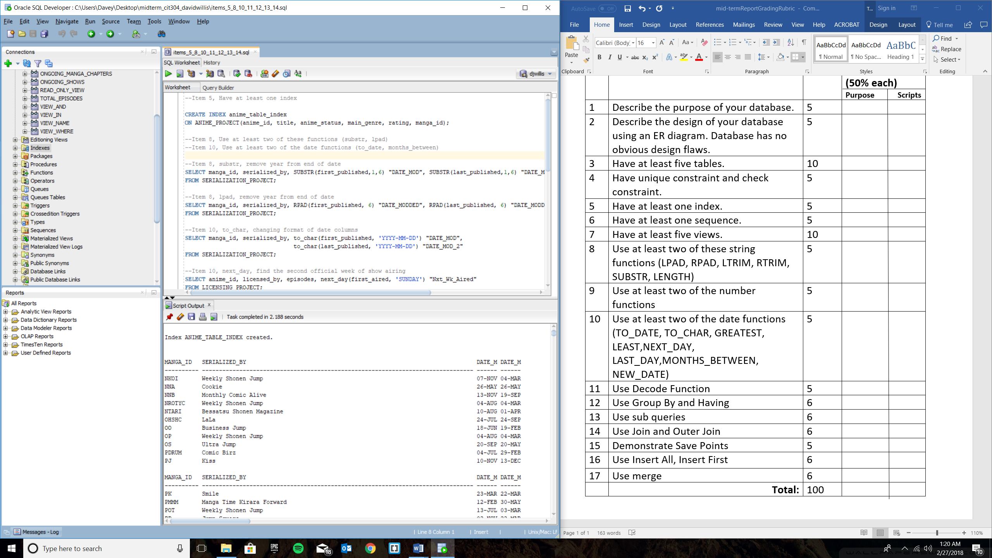

**--Item 8, Use at least two of these functions (substr, lpad)**

**--Item 10, Use at least two of the date functions (to_date, months_between)**

**--Item 8, substr, remove year from end of date**

**SELECT manga_id, serialized_by, SUBSTR(first_published,1,6) "DATE_MOD", SUBSTR(last_published,1,6) "DATE_MOD_2"**

**FROM SERIALIZATION_PROJECT;**

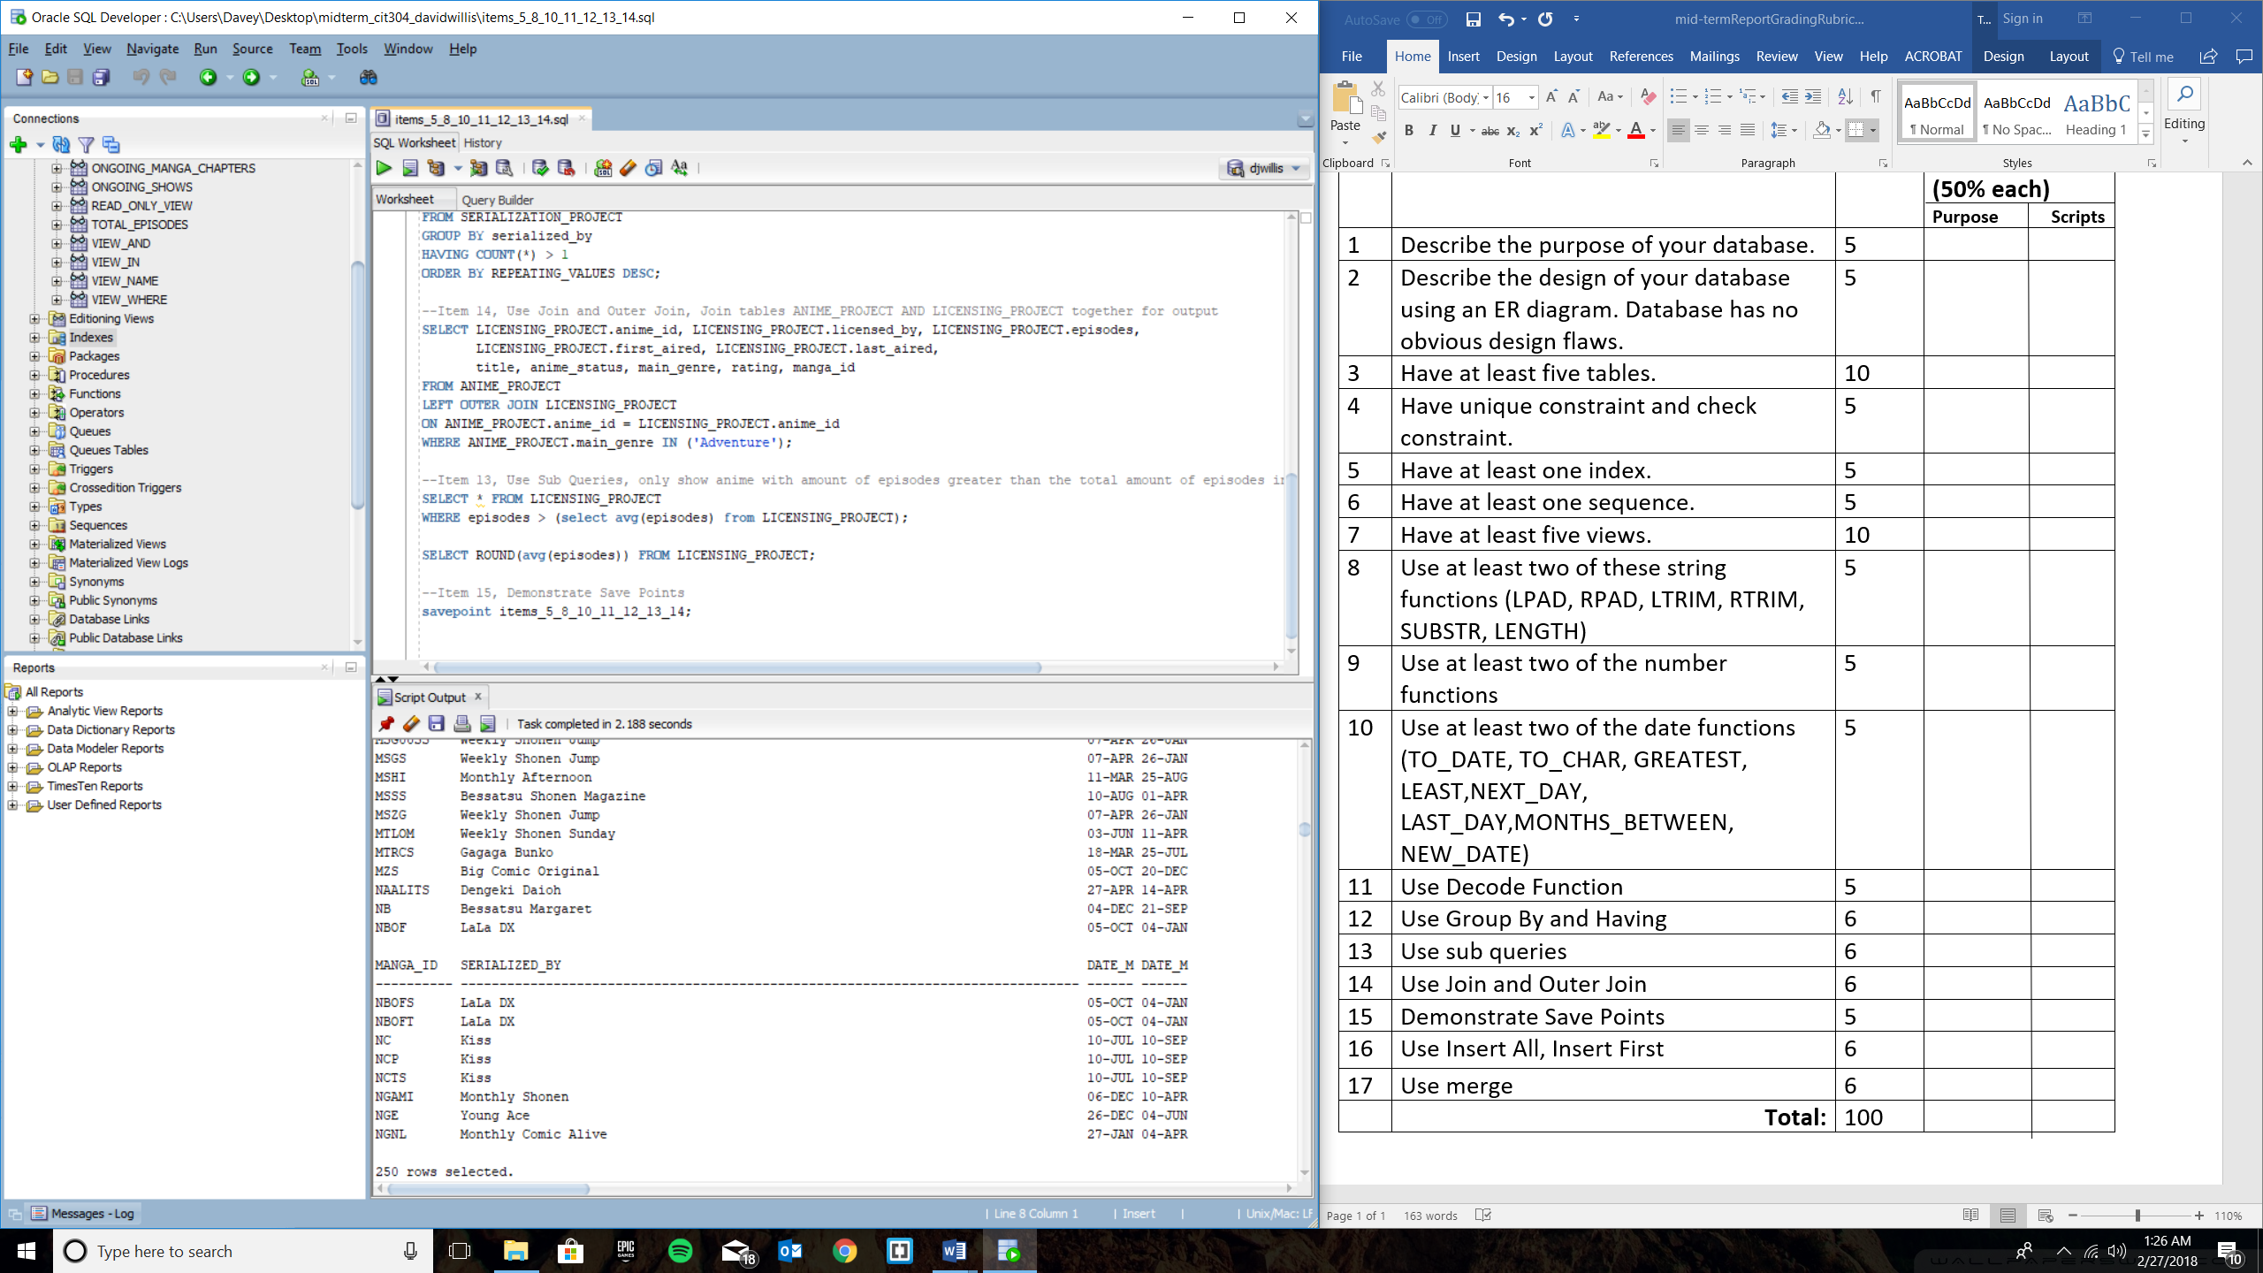

**--Item 8, lpad, remove year from end of date**

**SELECT manga_id, serialized_by, RPAD(first_published, 6) "DATE_MODDED", RPAD(last_published, 6) "DATE_MODDED_2"**

**FROM SERIALIZATION_PROJECT;**

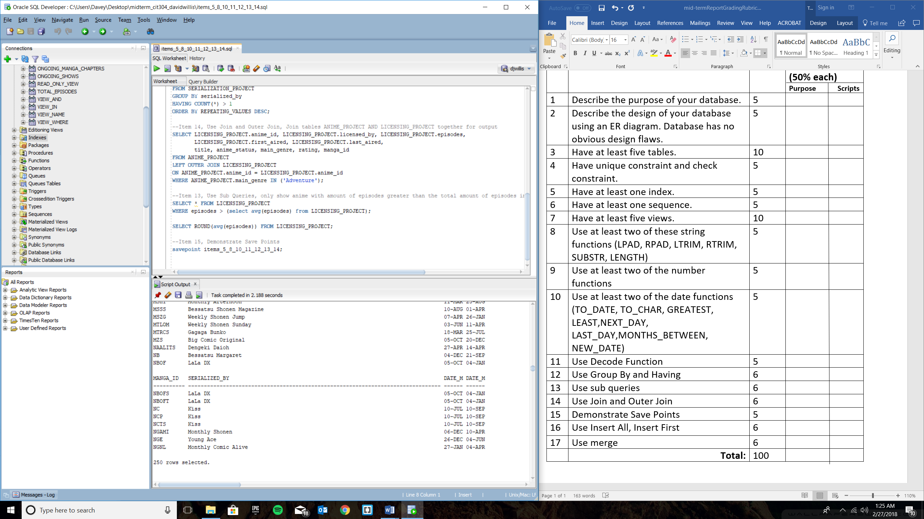

**--Item 10, to_char, changing format of date columns**

**SELECT manga_id, serialized_by, to_char(first_published, 'YYYY-MM-DD') "DATE_MOD",**

**to_char(last_published, 'YYYY-MM-DD') "DATE_MOD_2"**

**FROM SERIALIZATION_PROJECT;**

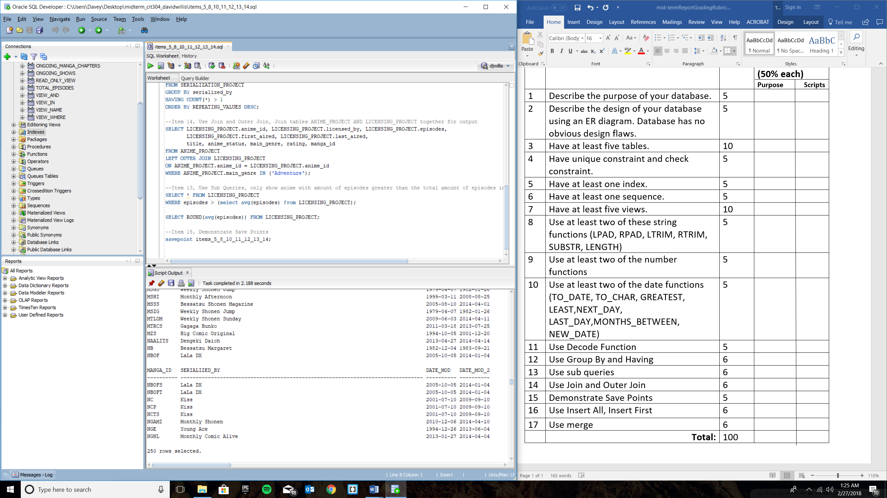

**--Item 10, next_day, find the second official week of show airing**

**SELECT anime_id, licensed_by, episodes, next_day(first_aired, 'SUNDAY') "Nxt_Wk_Aired"**

**FROM LICENSING_PROJECT;**

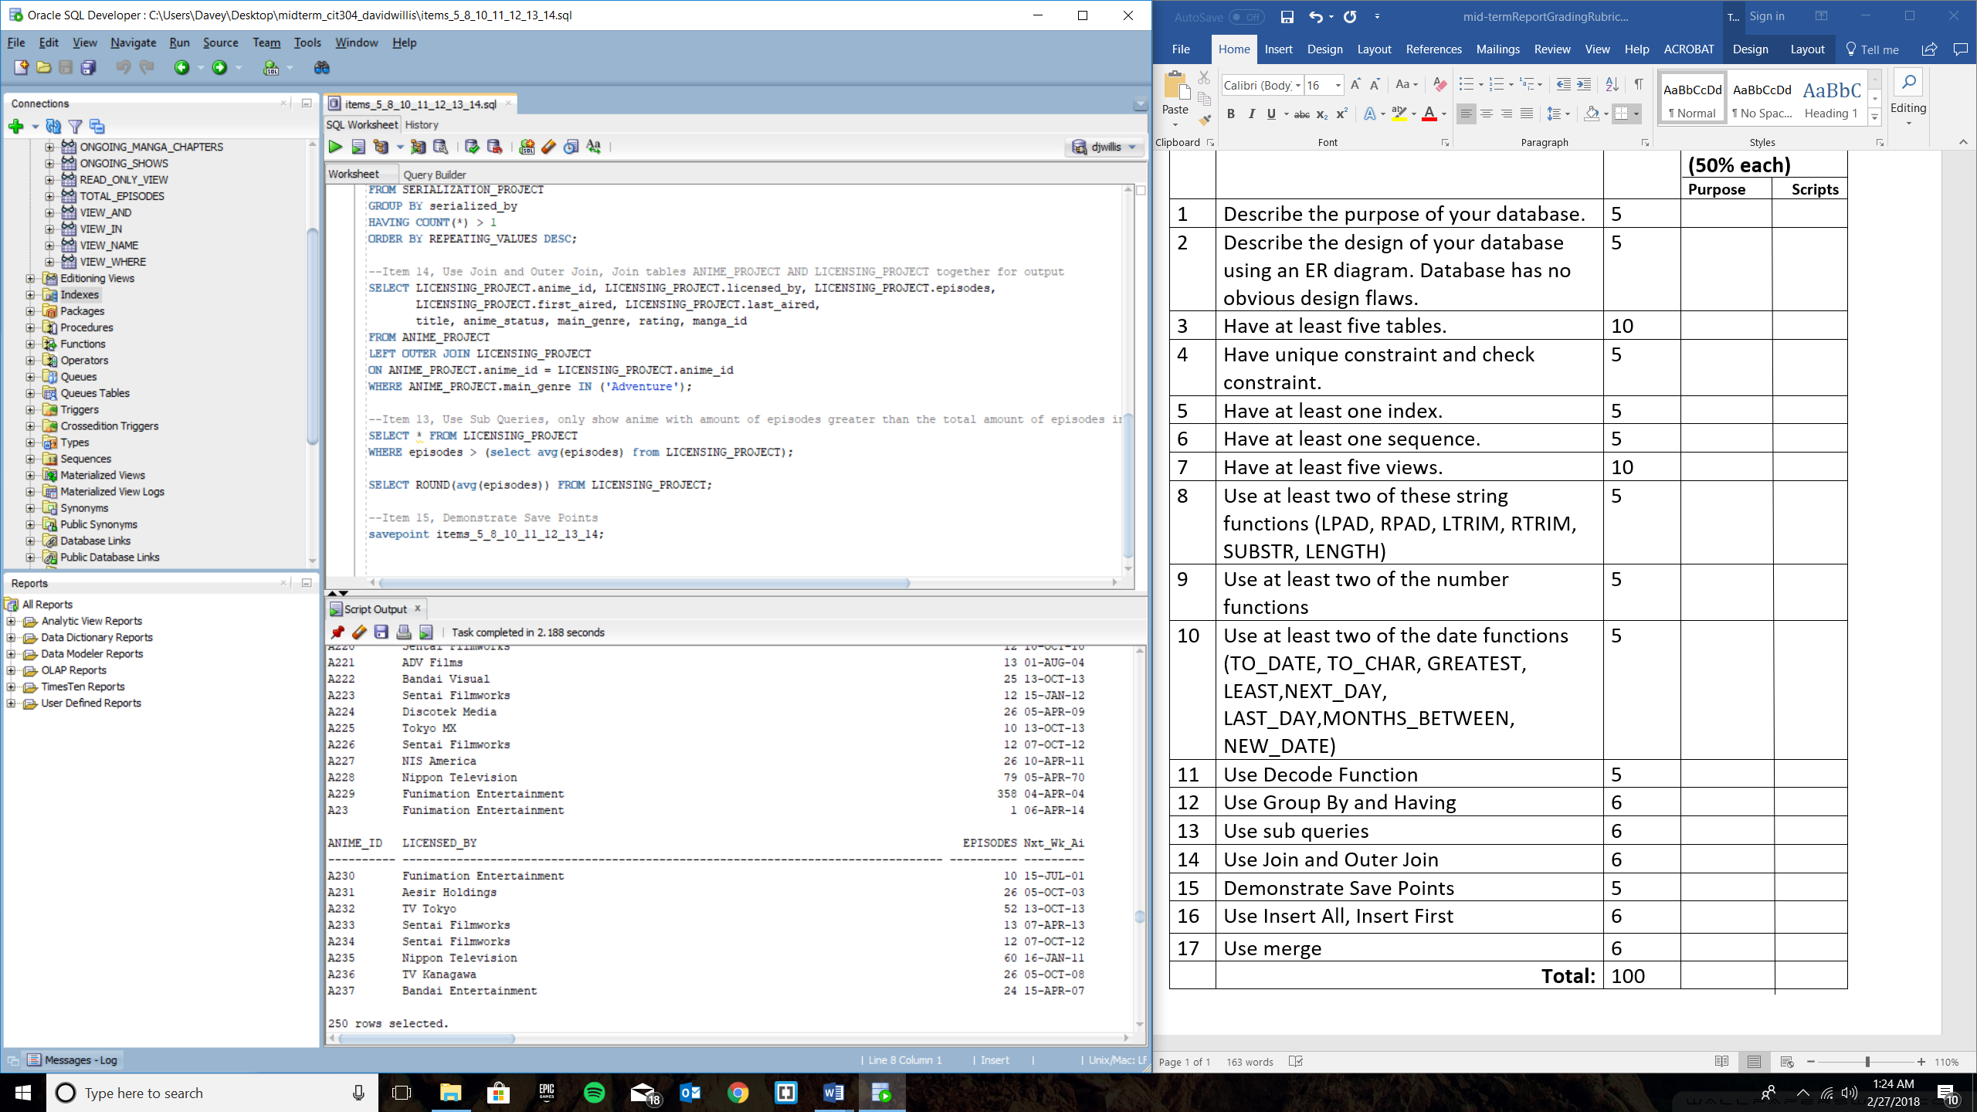

**--Item 11, Use Decode Function, Change 'Completed' status to "Finishing Airing' and 'Ongoing' status to 'Still Airing'**

**SELECT anime_id, title,**

**DECODE (anime_status, 'Completed', 'Finished Airing',**

**'Ongoing', 'Still Airing')**

**"Air Status"**

**FROM ANIME_PROJECT;**

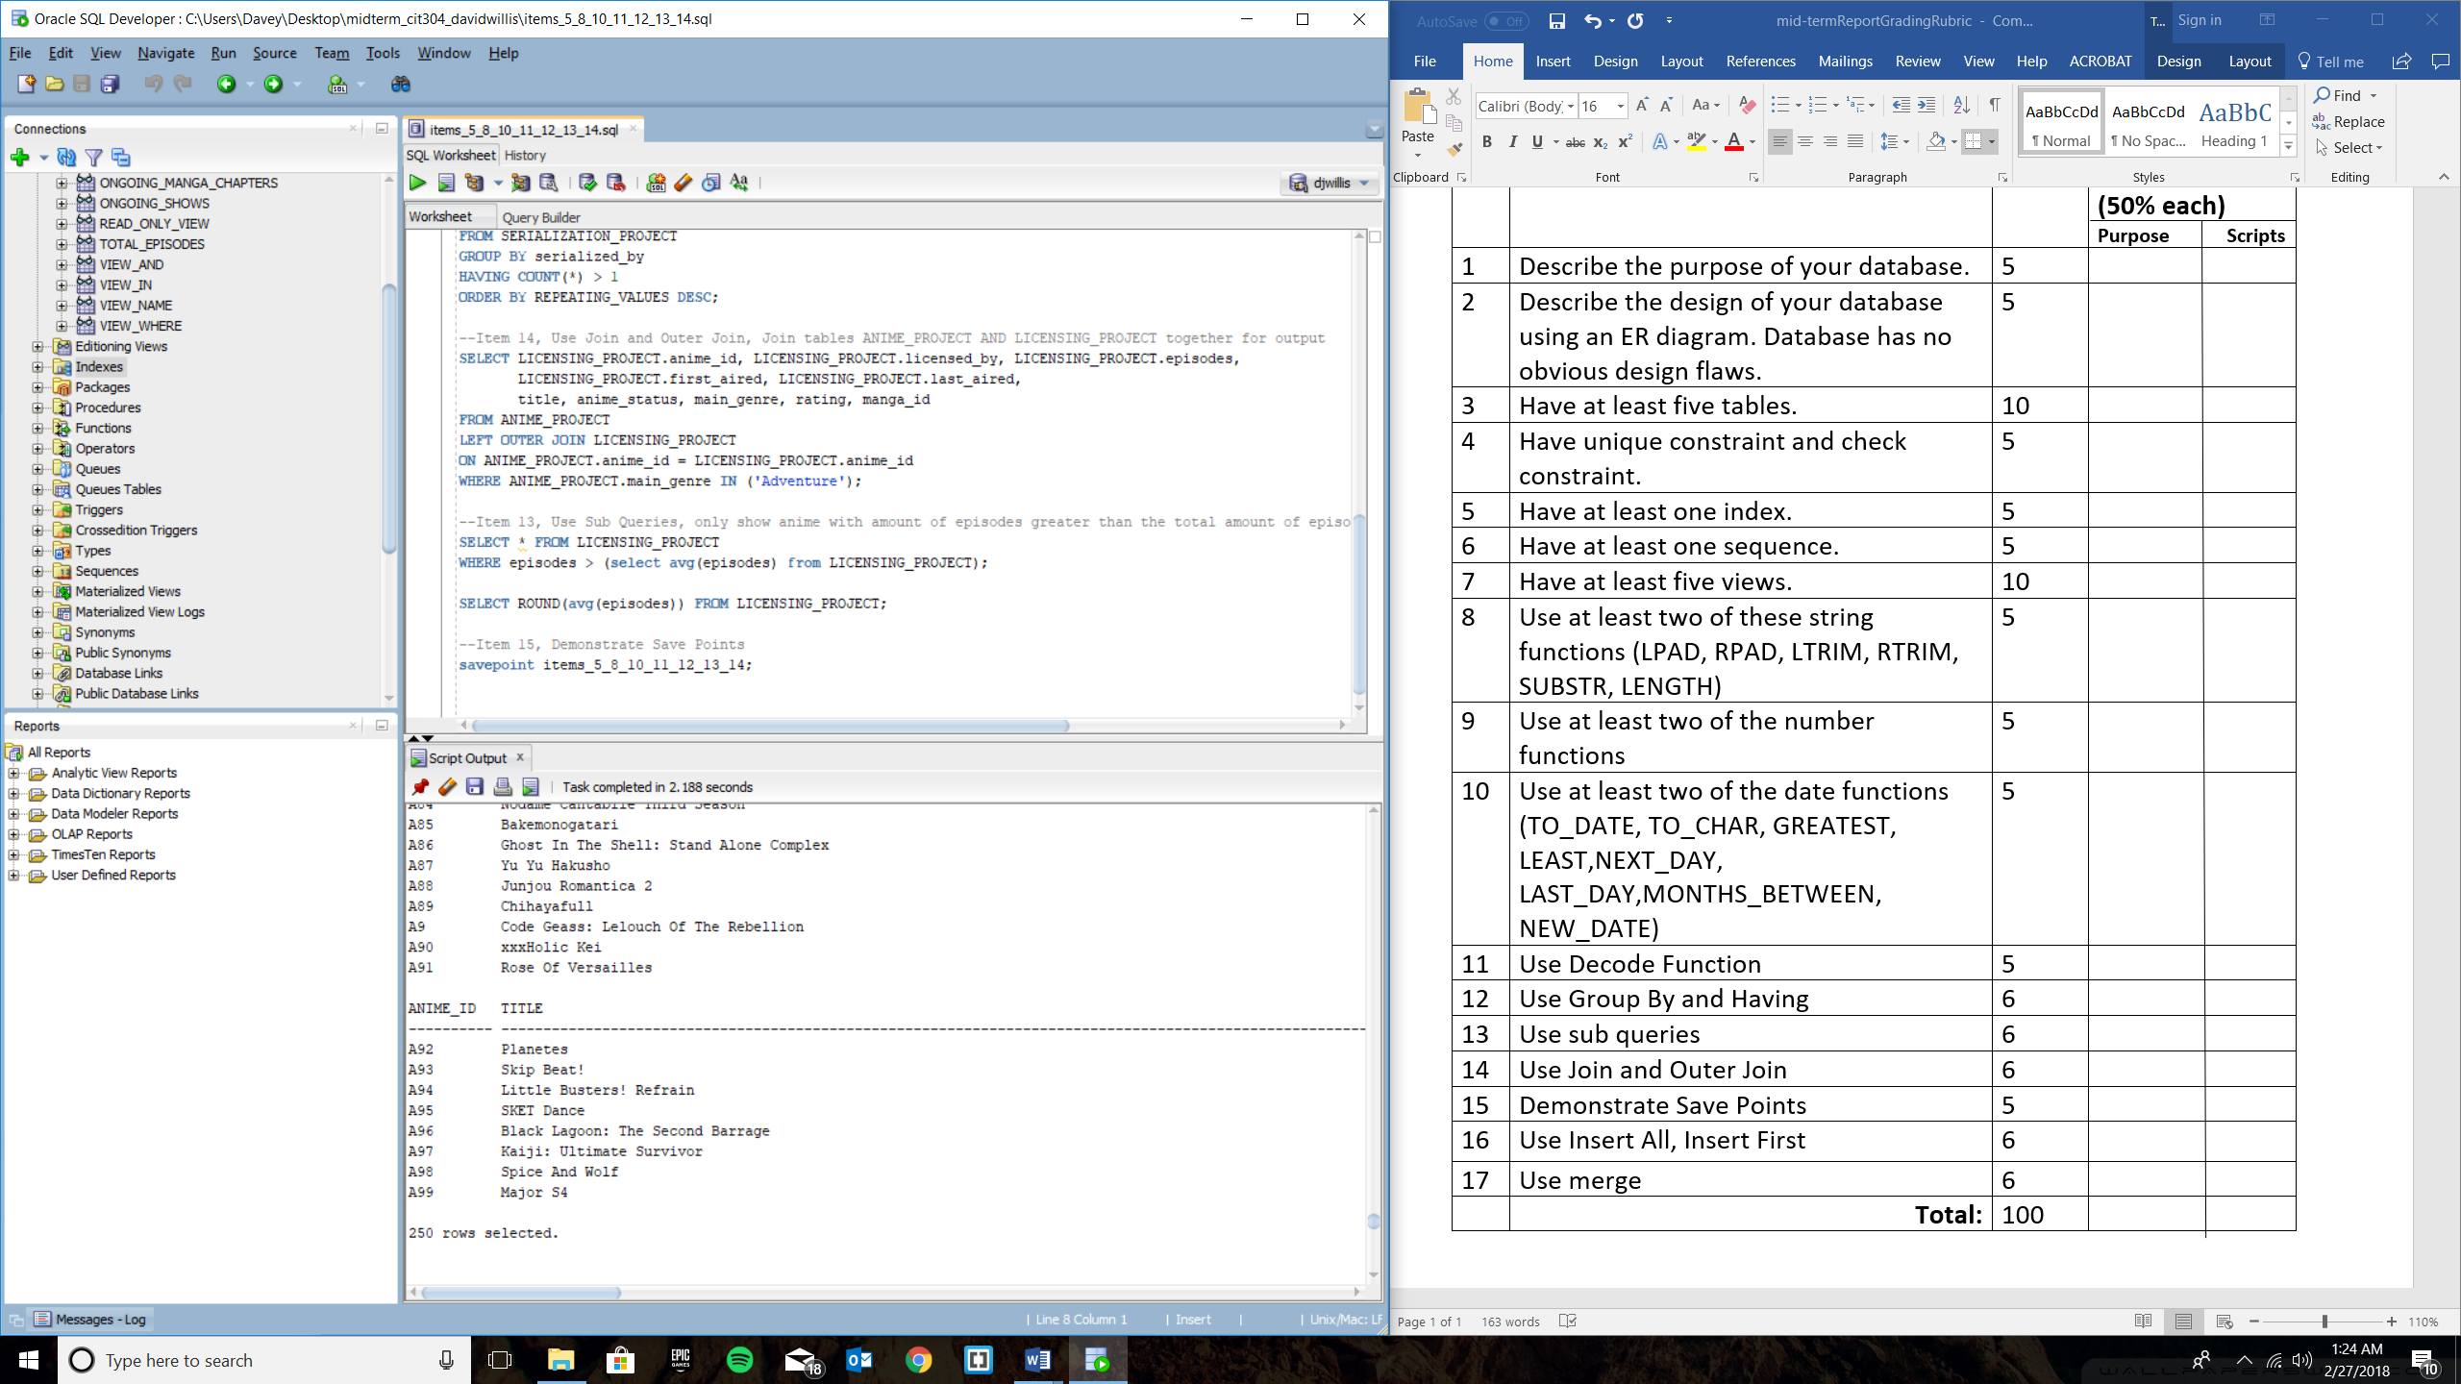

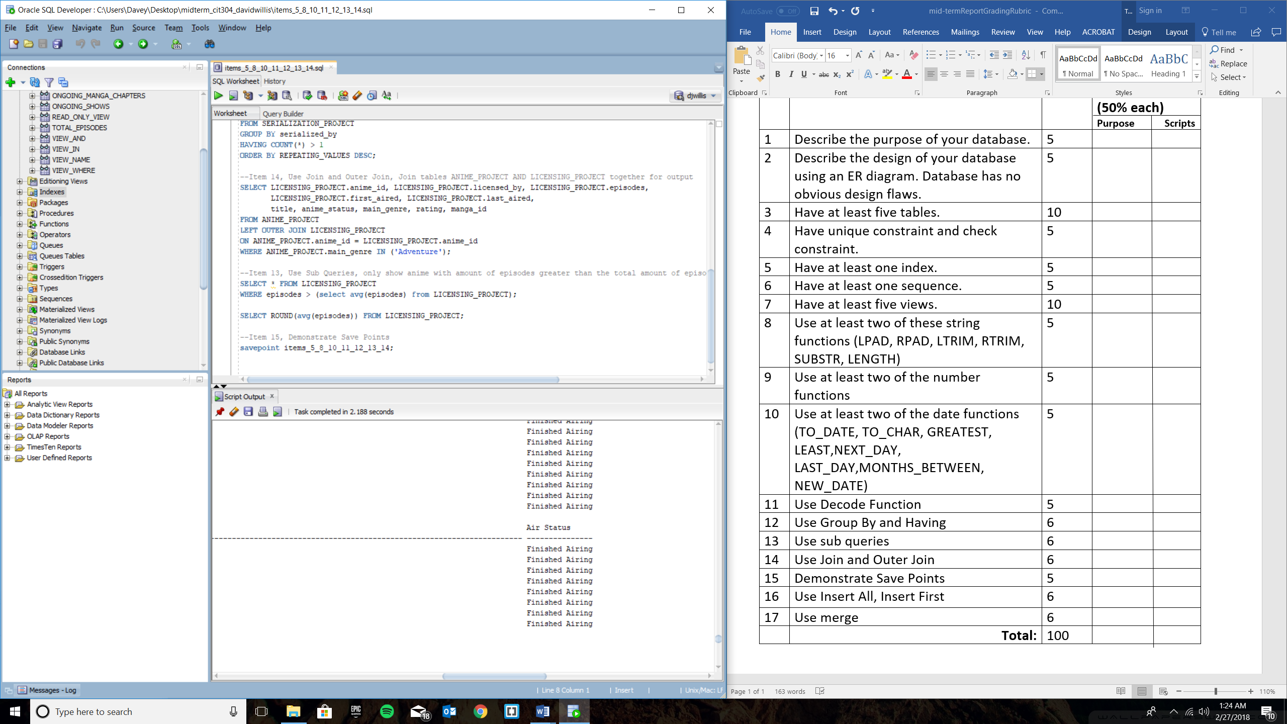

**--Item 12, Use Group By and Having, show how many repeating manga publishing companies in the top anime database AND show top manga publishing companies**

**SELECT serialized_by, COUNT(*) REPEATING_VALUES**

**FROM SERIALIZATION_PROJECT**

**GROUP BY serialized_by**

**HAVING COUNT(*) > 1**

**ORDER BY REPEATING_VALUES DESC;**

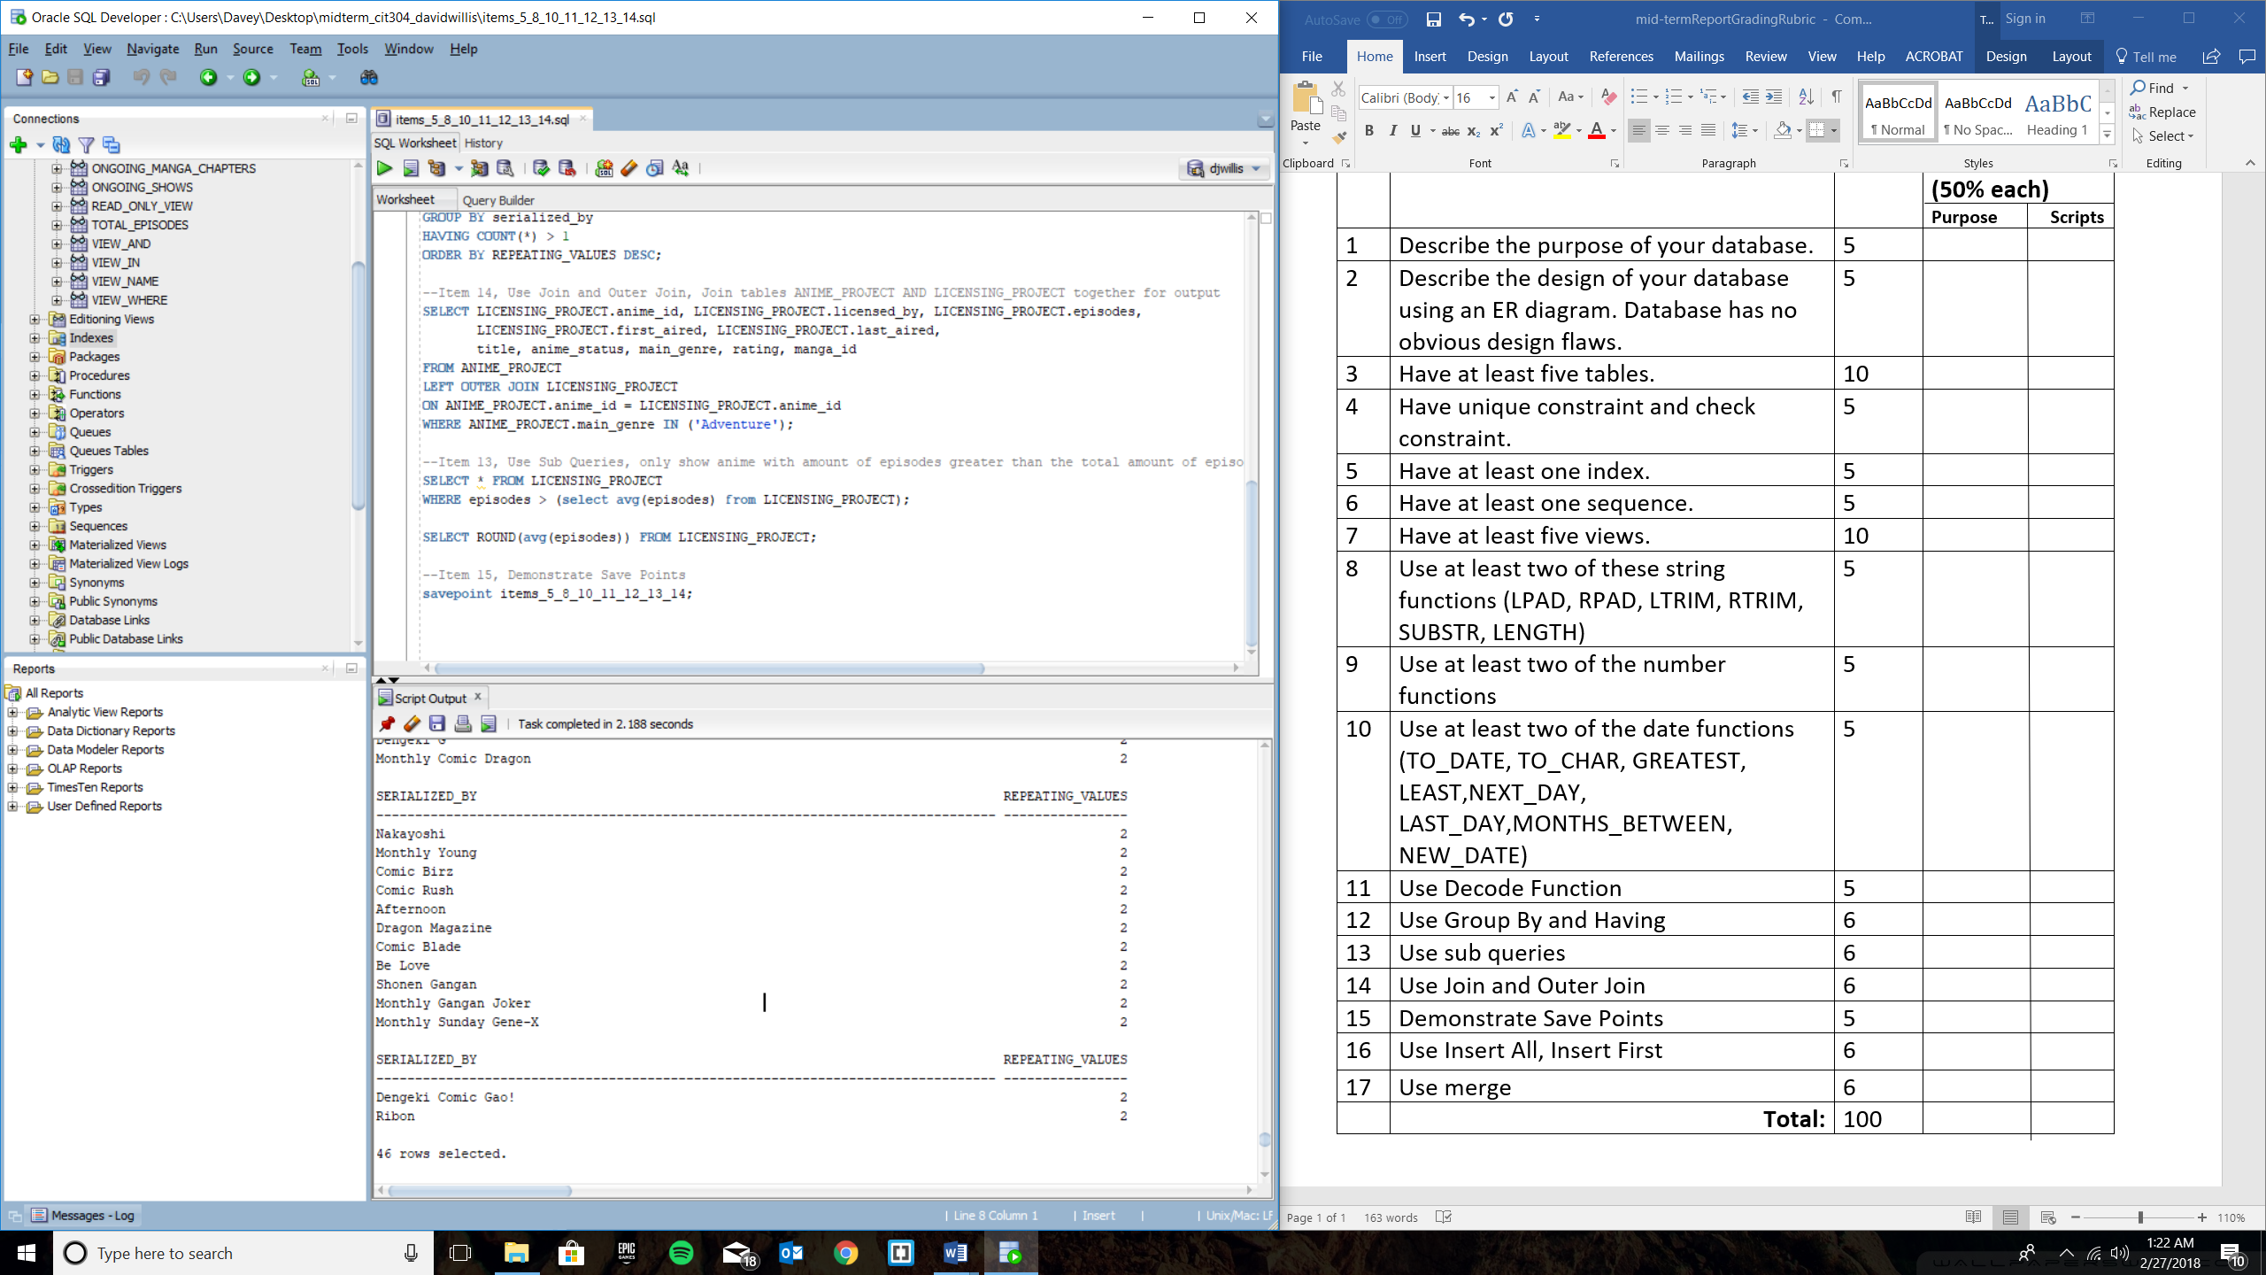

**--Item 14, Use Join and Outer Join, Join tables ANIME_PROJECT AND LICENSING_PROJECT together for output**

**SELECT LICENSING_PROJECT.anime_id, LICENSING_PROJECT.licensed_by, LICENSING_PROJECT.episodes,**

**LICENSING_PROJECT.first_aired, LICENSING_PROJECT.last_aired,**

**title, anime_status, main_genre, rating, manga_id**

**FROM ANIME_PROJECT**

**LEFT OUTER JOIN LICENSING_PROJECT**

**ON ANIME_PROJECT.anime_id = LICENSING_PROJECT.anime_id**

**WHERE ANIME_PROJECT.main_genre IN ('Adventure');**

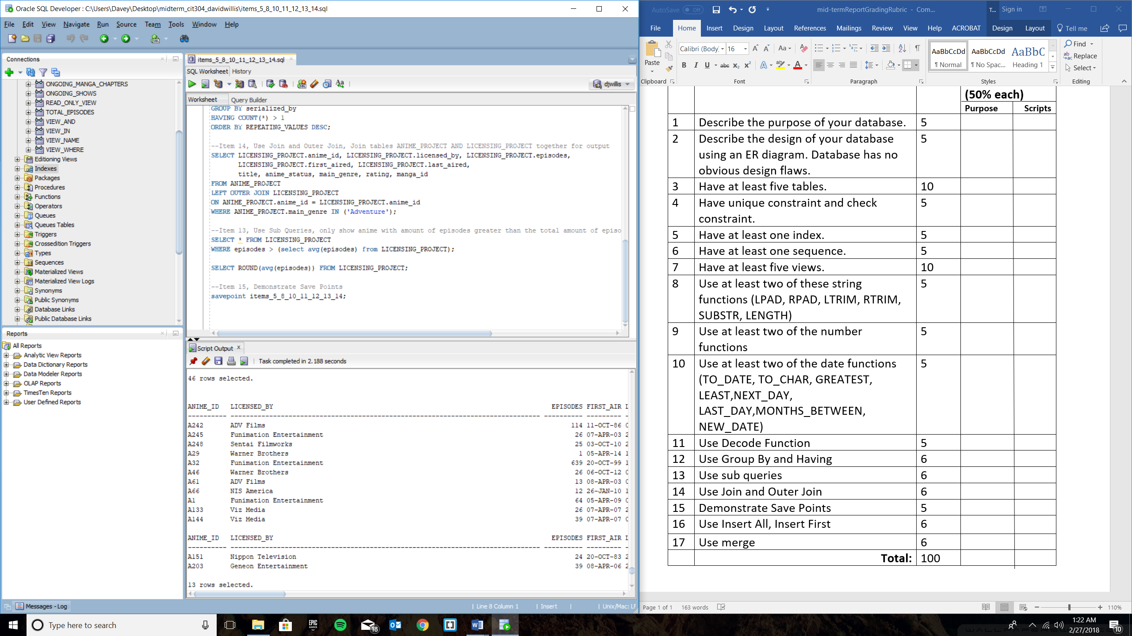

**--Item 13, Use Sub Queries, only show anime with amount of episodes greater than the total amount of episodes in database**

**SELECT * FROM LICENSING_PROJECT**

**WHERE episodes > (select avg(episodes) from LICENSING_PROJECT);**

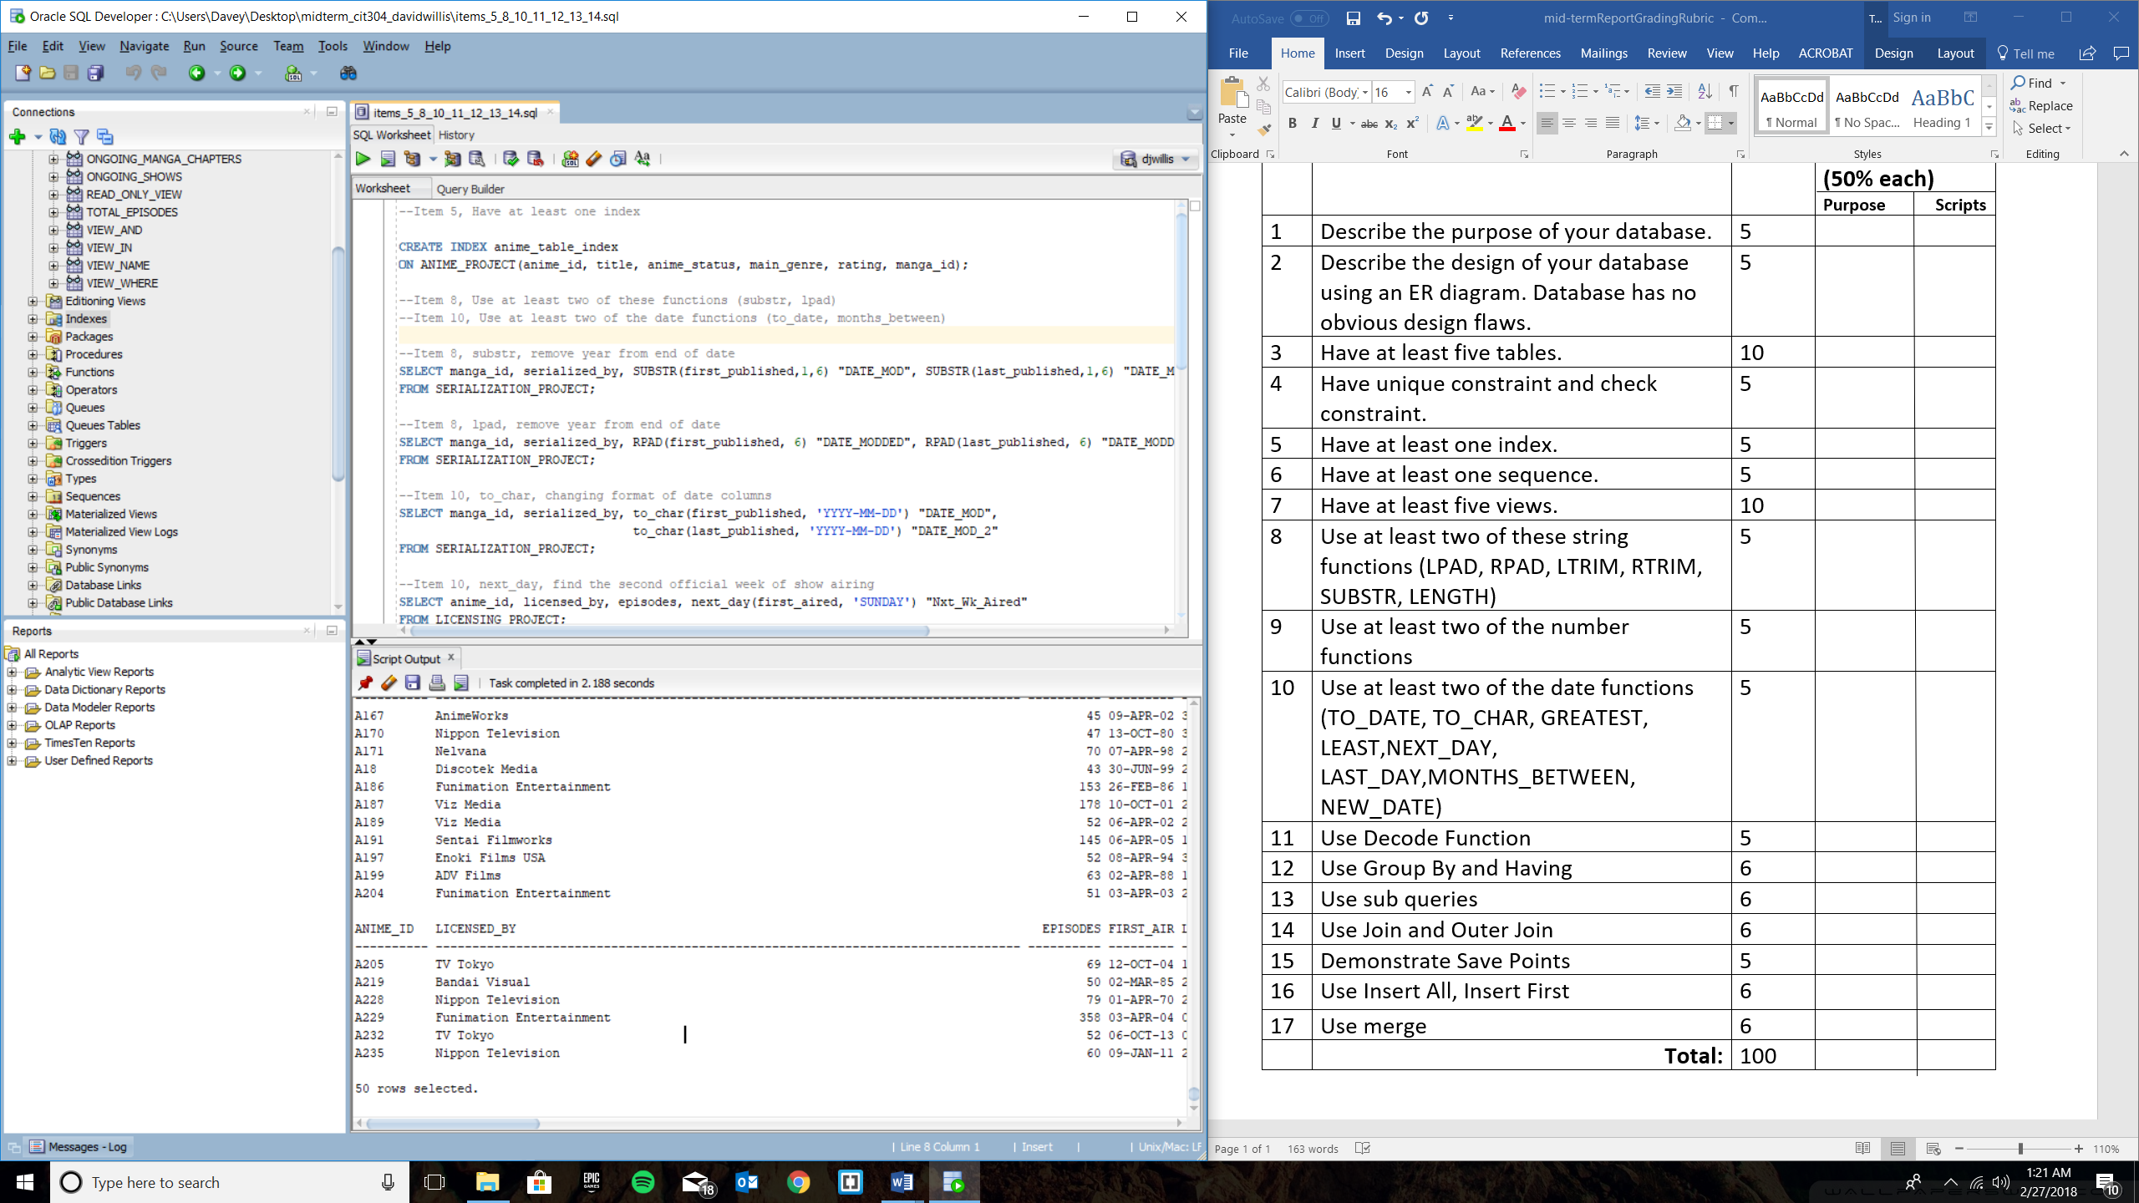

**SELECT ROUND(avg(episodes)) FROM LICENSING_PROJECT;**

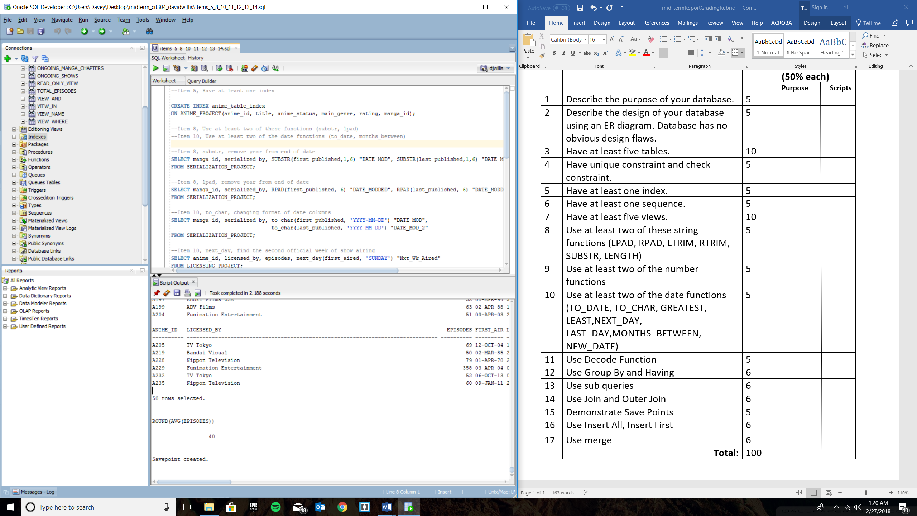

**--Item 15, Demonstrate Save Points**

**savepoint items_5_8_10_11_12_13_14;**

